Regional Healthcare Partnerships 8 and 17
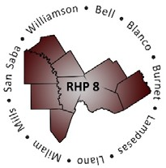
Joint Quarterly Regional Update
Thursday, May 30, 2019
10:00 a.m. – 11:30 a.m. (via WebEx)
Texas A&M Health Science Center

WebEx Link: Join WebEx Meeting
Meeting Number: 925 266 864

Audio/Conference Line: (Do not use the number provided by WebEx)
Dial in: 877-931-8150
Participant Code: 3621413

AGENDA

- Welcome/Introductions

- Uncompensated Care (UC) Update
  - DY8 UC Reporting Reminders and Timeline
  - DY9-11 UC Update Brief

- Delivery System Reform Incentive Payment (DSRIP) Update
  - April DY8 Reporting Recap and Pending Activities
  - Brief Compliance Monitoring Update
  - DY8 Learning Collaborative Activities

- Texas 1115 Waiver RHP Update (DY9-10)
  - Update on drafts of DY9-10 DSRIP Protocols
  - Timeline of Texas Due Dates to CMS
  - Regional Considerations
  - Draft Timeline for DY9-10 RHP Plan Submission

- Open Discussion/Q&A

- Wrap-Up/Adjourn
  - Upcoming Regional Events

