Regional Healthcare Partnership 17
Biannual Learning Collaborative Event
sponsored by
Faith Mission
March 25, 2015 • 11:30 a.m. – 3:30 p.m.
The Faith Mission Cannery Kitchen
314. E. Alamo Street
Brenham, Texas 77833

Agenda

Registration and “Raise the Floor” Networking Luncheon provided by Faith Mission with Project Poster Display
11:30 – 12:30 p.m.
{Break/Late Registration 12:30 – 12:45 p.m.}

- Welcome and Introductions
(12:45 – 1:00 p.m.) Honorable John Brieden, Washington County Judge
Reverend Randy Wells, Faith Mission
Anchor Team

- Hunger Statistics and Nutrition in Texas
(1:00 – 1:35) John Puder, M.P.Aff., Hunger Outreach Specialist, No Kid Hungry Regional
Coordinator
Texas Hunger Initiative, Baylor University School of Social Work
Q&A with John Puder (1:35-1:55)
{Break 1:55 – 2:05}

- RHP 17 Spotlight on Nutrition and Chronic Disease Management
(2:05 – 2:25) Evidence-based Programs for Chronic Disease Management
Rachel Coughlin, Graduate Assistant, Evidence-Based Programs
Texas A&M Health Science Center School of Public Health

(2:30 – 2:50) Collaborative Nutrition Education & Outreach in Washington County
Jennifer Mertz, Director, Community Clinic
Baylor Scott & White Hospital Brenham
Q&A with Rachel Coughlin & Jennifer Mertz (2:50-3:10)

- Closing Remarks and Adjourn
(3:10 – 3:30 p.m.) Anchor Team

Regional Healthcare Partnership 17
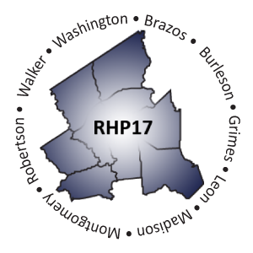
Biannual Learning Collaborative Event
sponsored by
Faith Mission
March 25, 2015 • 11:30 a.m. – 3:30 p.m.
The Faith Mission Cannery Kitchen
314. E. Alamo Street
Brenham, Texas 77833

Event Speakers

John M. Puder -- Child Hunger Outreach Specialist, No Kid Hungry Regional Coordinator; Texas Hunger Initiative, Baylor University School of Social Work
John M. Puder earned his Bachelor of Arts from the University of Texas at San Antonio and a Master of Public Affairs from the Lyndon B. Johnson School of Public Affairs at the University of Texas at Austin. A native of San Antonio, John served as a consultant and advisor to multiple elected officials including former Congressman Ciro Rodriguez and Councilwoman Elena Guajardo. After relocating to Houston, John served as Outreach Coordinator for Systems of Hope. He currently serves as the Child Hunger Outreach Specialist for the THI Houston Region.

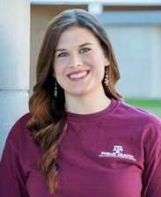
Rachel Coughlin – Graduate Assistant, Texas A&M Evidenced-Based Programs, Texas A&M Health Science Center School of Public Health
Rachel Coughlin is a Graduate Assistant for Texas A&M Evidence-Based Programs. She earned a Bachelor of Science degree in Psychology and Human Development from the University of Wisconsin-Green Bay and is currently pursuing a Master of Public Health degree. While attending the Texas A&M Health Science Center School of Public Health for her graduate degree, she is also earning a Certificate in Non-Profit Management from The Bush School of Government and Public Service. She has previous experience in motivational speaking, behavior research, autism therapy, as well as fitness and nutrition education and promotion.

Jennifer Mertz – Director, Community Clinic, Baylor Scott & White Hospital – Brenham
Jennifer Mertz is the director of the community clinic, as well as provides educational services, employee health, and provides services within the Wellness & Diabetes Center and Sleep Center at Scott & White Hospital in Brenham. She is a registered nurse and holds a Master of Science in Nursing. In addition to the service areas above, Jennifer also assists with implementation and oversight of the hospital’s two DSRIP projects that serve Washington County patients and expand collaboration with community partners including Faith Mission.

