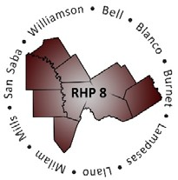
Regional Healthcare Partnerships 8 and 17
Joint Regional Update Meeting
Friday, December 11, 2015 • 9:00 a.m. – 10:00 a.m.

TAMHSC Round Rock Campus – Rm S100
TAMHSC Bryan Campus – Rm LL-11B

AGENDA

Welcome and Introductions

- Uncompensated Care (UC) Updates
  - DY4 Final UC Payment Timeline & Requirements
  - DY5 UC Reporting Process & Payment Timeline
  - Latest CMS Deferral Update

Delivery System Reform Incentive Payment (DSRIP) Update
  - DY4 October Reporting Review Status
  - DY4 October Payment Timeline
  - Compliance Monitoring Process & Timeline

Texas 1115 Waiver Extension/Renewal Update
  - Brief Overview of Extension/Renewal Process & Timeline
  - HHSC Proposed Changes to DSRIP Program
  - Regional Considerations & Unknowns

Open Discussion/Q&A

Adjourn

