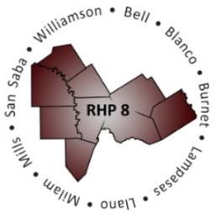
Regional Healthcare Partnerships 8 and 17
Joint Monthly Learning Collaborative Webinar
Thursday, February 11, 2016 • 10:00 a.m. – 11:00 a.m.
Audio: Phone: 877-931-8150 • Participant Passcode: 1624814
Webinar: Join WebEx meeting • Meeting Number: 922 270 306

AGENDA
- Welcome and Introductions
- Upcoming Learning Collaborative Opportunities
- Save the Date: RHP 8 Behavioral Health and Primary Care Cohort
Date: Thursday, February 18 (Standing meeting: Third Thursday of each month)
Time: 11:30 a.m. - 1:30 p.m. (brown bag)
Location: Bluebonnet Trails Community Services, 1009 N. Georgetown St., Round Rock, 78664

- Save the Date: RHP 17 Cohort
Date: Thursday, February 18 (Standing meeting: Third Thursday of each month)
Time: 9:30 a.m. - 11:30 a.m.
Location: TBD

- Save the Date: Joint RHP 8 & 17 Events
Date: Thursday, March 24, 2016
Location: Texas A&M Health Science Center – Round Rock Campus
Joint Managed Care Forum: 9:00 – 11:15 a.m.
Exploring Common Ground: Potential Alignment of Regional Programs & Managed Care Initiatives
Joint Learning Collaborative Event with Lunch: 11:30 a.m. – 3:00 p.m.
Project Sustainability and Waiver Renewal
- “Raise the Floor” – Focus Areas and Open Discussion
- Presentation: Program Evaluation Series
RHP 8 Anchor Team, “Program Results Stories”
Presentation will provide a brief overview of program results stories as a method for program evaluation and sustainability including a framework, resources, and examples.

- Open Discussion

- Next Steps/Adjourn
Next RHP 8 and 17 Joint Webinar: Thursday, March 10, 10:00 a.m.

