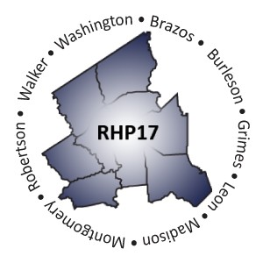
Regional Healthcare Partnership 17 Cohort Workgroup Meeting
June 16, 2016 ● 9:30 ‐ 11:30 a.m.
Rural & Community Health Institute 2700 Earl Rudder Freeway, Suite 3000 College Station, TX 77845
Conference Line: 877‐931‐8150 ● Participant Code: 1624814
AGENDA

- Welcome and Introductions
Debbie Muesse, Rural & Community Health Institute

- Cohort Update: Program Funding & Mechanics Protocol (DY6)
Shayna Spurlin, RHP 17 Anchor Team

- Open Discussion: Regional Transition Year/PFM Feedback for HHSC
Group discussion facilitated by Anchor Team

- Wrap‐Up
RHP 17 Anchor Team
  - Discuss Next Steps
  - Review Upcoming Events/Reminders

Please be prepared to actively contribute to development of this group involving providers and community partners in the region who seek to positively impact patient care, improve services and access, and strengthen the Region 17 health system infrastructure through collaboration and sharing of multiple perspectives across the spectrum of healthcare.

