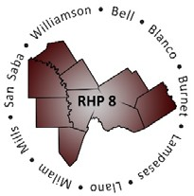
Regional Healthcare Partnerships 8 and 17
Joint Regional Update Meeting
Wednesday, April 15, 2015 • 1:30 p.m. – 3:30 p.m.
College Station Medical Center CSMC Classroom
1651 Rock Prairie Road • College Station, TX 77845
Conference Line: 877‐931‐8150 • Participant Code: 1624814

AGENDA

Welcome and Introductions

CMS Deferral Update

- Uncompensated Care (UC) Updates
  - DY3 Final UC Payment Timeline
  - DY4 Advanced UC Payment Timeline

Delivery System Reform Incentive Payment (DSRIP) Update
  - IGT Requests for DY4 Monitoring
  - DY4 April Reporting & Payment Timeline
  - Brief Overview of Cooper Online Reporting System

Regional Health Partnership (RHP) Plan Update
  - Brief Recap of Revision Process to Date
  - Public Access to Revised Projects & Plans
  - Plan Certification & Resubmission Timeline

Texas 1115 Waiver Extension/Renewal Update
  - Brief Overview of Extension/Renewal Process & Timeline
  - Current Status of Extension/Renewal Activities
  - Potential Considerations & Unknowns

Open Discussion/Q&A Adjourn

