Regional Healthcare Partnerships 8 and 17
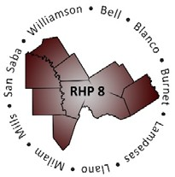
Joint Quarterly Regional Update
Thursday, August 29, 2019
10:00 a.m. – 11:30 a.m. (via WebEx)
Texas A&M Health Science Center

WebEx Link: Join WebEx Meeting
Meeting Number: 929 949 769

Audio/Conference Line: (Do not use the number provided by WebEx)
Dial in: 877-931-8150
Participant Code: 3621413

AGENDA

- Welcome/Introductions

- Uncompensated Care (UC) Update
  - DY8 UC Reporting Process and Timelines
  - DY9-11 UC Update Brief

- Delivery System Reform Incentive Payment (DSRIP) Update
  - October DY8 Reporting Reminders and Prep
  - Brief Compliance Monitoring Update
  - DY8 Learning Collaborative Activities

- Texas 1115 Waiver RHP Update (DY9-10)
  - HHSC DY9-10 Timeline and Protocol Updates
    - Program Funding and Mechanics
    - Measure Bundle Protocol
    - DSRIP Transition Plan and Timeline
  - Regional Considerations
  - RHP 8 and 17 Proposed DY9-10 Plan Submission Timeline

- Open Q&A/Wrap-Up

