Regional Healthcare Partnerships 8 and 17
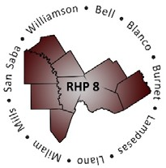
Joint Quarterly Regional Update
Thursday, December 17, 2020
10:00 AM – 11:30 AM (via Zoom Webinar)
Texas A&M University Health Science Center

Webinar Link: Join Zoom Meeting
Meeting Number: 981 9010 6622
Meeting Password: 158473

Audio/Conference Line: 877-931-8150; Code: 3621413

AGENDA

- Welcome/Introductions

- Uncompensated Care (UC) Update

- Delivery System Reform Incentive Payment (DSRIP) Update

- Texas 1115 Waiver Update
  - COVID-19 Brief Updates (Waiver-Related)
  - Five-Year Fast-Track Extension Request (November 2020)
  - One-Year DSRIP Extension Request (October 2020)
  - DSRIP Transition Plan Update

- Open Q&A/Wrap-Up

