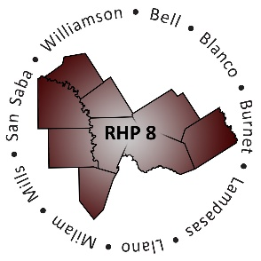
RHP 8 and RHP 17
DY7 Biannual Learning Collaborative Event

Georgetown Health Foundation
Monday, September 24, 2018
Community Rooms
9:30 a.m. – 3:00 p.m.
AGENDA
Time | Item/Speaker | Topics
9:30 am  10:00 am | Registration & Networking | Sign-in, Network
10:00 am  10:05 am | Shayna Spurlin  Associate Director, 1115 Anchor Teams  Texas A&M Health Science Center | Welcome & Introductions
10:10 am  10:45 am | Kathy Lee  Director and RHP 16 Anchor  Coryell Memorial Healthcare System | Overview and Update:  HHSC Value-Based Payment and Quality Improvement Committee
10:50 am  11:40 am | Tiffany J. Berry, MD  Chief Medical Officer, Central Texas Division  Baylor Scott & White Quality Alliance | Provider System Spotlight:  Baylor Scott & White Health’s Accountable Care Organization
11:40 am  11:50 am | Break: Pick up lunch
11:50 am  12:50 pm | Lunch with Networking Activity | Raise The Floor – Critical Thinking and Discussion Around VBP/APM Opportunities and Challenges
12:50 pm  1:00 pm | Break: Lunch clean up
1:05 pm  1:50 pm | Lisa Kirsch  Senior Policy Director  Dell Medical School | Value-Based Purchasing in Texas
1:55 pm  2:30 pm | Amanda Broden  Manager, Healthcare Transformation Waiver Operations  Texas Health & Human Services Commission | Texas 1115 Medicaid Waiver Update
2:30 pm  2:45 pm | Shayna Spurlin  Associate Director, 1115 Anchor Teams  Texas A&M Health Science Center | Closing Remarks

