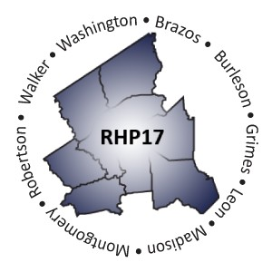
Regional Healthcare Partnership 17
Thursday, September 21, 2017 • 10:30 a.m. – 12 p.m.
Regional Public Meeting: DY7-8 Unallocated Funds Process
Texas A&M Health Science Center
Williams Conference Room, Rural & Community Health Institute 2700 Earl Rudder Frwy S, Suite 3000
College Station, Texas 77845
OR
via WebEx Meeting (meeting #927 120 559)
Audio: 877-931-8150 (participant code 3621413)

AGENDA

- Welcome and Introductions

- Review DY7-8 Unallocated Funds Process

- Review Scoring Process and Results
  - Recap of Proposal and Scoring Processes
  - Summary of RHP 17 Proposal Scores and Rankings

Review Funding Allocation Methods
  - Overview of Initial Allocation Process and Survey
  - Summary of Regional Allocation and Funding Requests
  - Overview of Funding Options Proposed to Region
  - Results of RHP 17 Allocation Method/Award Survey
  - Review (draft) Final DY7-8 Prioritized List

Open Discussion/Q&A

- Anticipated Timelines and Next Steps
  - Updates from HHSC (if any)
  - IGT Communication and Required Final Confirmation

Adjourn

