Regional Healthcare Partnerships 8 and 17
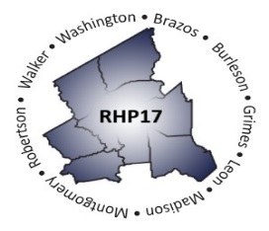
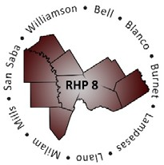
Joint Quarterly Regional Update
Thursday, August 27, 2020
10:30 AM – 12:00 PM (via Zoom Webinar)
Texas A&M Health Science Center

Webinar Link: Join Zoom Meeting
Meeting Number: 998 0420 5213
Meeting Password: 411696

Audio/Conference Line: Dial in: 877-931-8150; Code: 3621413

AGENDA

- Welcome/Introductions

- Texas 1115 Waiver Update (COVID-19 and DSRIP Transition)
  - DSRIP Transition Plan
  - COVID-19 Brief Updates (Waiver-Related)

- Uncompensated Care (UC) Update

- Delivery System Reform Incentive Payment (DSRIP) Update

- Other Waiver-Related Updates

- Open Q&A/Wrap-Up

