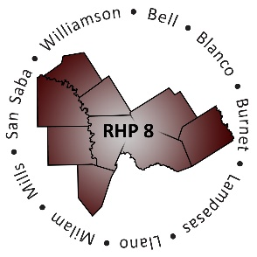
RHP 8 and RHP 17
DY6 Biannual Learning Collaborative Event

Georgetown Health Foundation
Wednesday, March 22, 2017
Community Rooms
9:00 a.m. – 2:30 p.m.
AGENDA
Time | Item/Speaker | Topics
9:00 am  9:45 am | Registration & Networking | Sign-in, Network, View Project Posters
9:45 am  9:55 am | Jennifer LoGalbo  Program Director, RHP 8 Anchor Team  Texas A&M Health Science Center | Welcome & Introductions
10:00 am  10:45 am | Andy Vasquez  Deputy Associate Commissioner for Quality  Texas Health & Human Services Commission | VBP in Texas: Medicaid Payment Reform Initiatives
10:50 am  11:25 pm | Kathy Lee  Director and RHP 16 Anchor  Coryell Memorial Healthcare System | Value-Based Payment and Quality Improvement Committee
11:30 am  11:55 am | Debbie Muesse  Program Manager, Brazos Valley Care Coordination Program  Texas A&M Rural & Community Health Institute | Provider Spotlight: The Path to a Pilot with Managed Care
12:00 pm  12:10 pm | Break: Pick up Lunch
12:15 pm  12:45 pm | Lunch with Networking Activity | Raise The Floor – Critical Thinking and Discussion Around VBP/APM Opportunities and Challenges
12:50 pm  1:25 pm | Yulanda Haynes-Mims  Director of Health Plan Reimbursement  Bluebonnet Trails Community Services | Provider Perspective/Experience: DSRIP MCO Alignment
1:30 pm  2:15 pm | Emily Sentilles  Program Specialist  Texas Health & Human Services Commission | Waiver Renewal Update
2:20 pm  2:30 pm | Shayna Spurlin  Associate Director, 1115 Anchor Teams  Texas A&M Health Science Center | Closing Remarks

