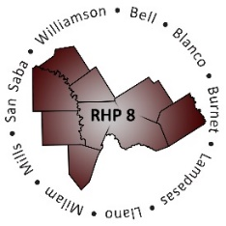

AGENDA
- Welcome/Introductions

- Review of Texas 1115 Waiver and updated Delivery System Reform Incentive Program (DSRIP) protocols

- RHP Plan Update: DY9-10 Plan Submission

  - RHP Plan Update Requirements
  - Review of Regional Plan Development
  - Review of Regional Planning Timeline
  - Review of Regional Community Needs Assessment

- Open Discussion/Questions and Answer

- Wrap-Up/Adjourn

