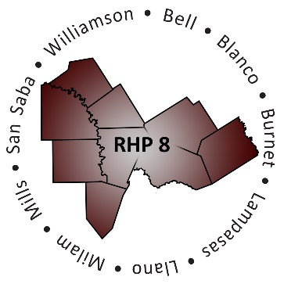

Regional Healthcare Partnership 8
Thursday, March 29, 2018 • 10 – 11 a.m.
Stakeholder Forum: RHP 17 Plan Update & DY7-8 Activities

Texas A&M Health Science Center Round Rock Campus
3950 A. W. Grimes Boulevard, Room 100
Round Rock, Texas 78665

OR

Join WebEx Meeting (Meeting Number: TBD)
Conference Line: 877-931-8150; code 3621413

AGENDA

- Welcome and Introductions

- Overview of Texas 1115 Waiver Renewal (DY7-11)

- Overview of DY7-8 RHP Plan Update
    - RHP Plan Update Requirements
    - Brief Recap of Revision Process & Timeline
    - Updated Community Needs Assessment
    - Updated Learning Collaborative Plan
    - Plan Certification/Verification
    - Public Access to RHP 17 Plan Update

- Regional Goals and Stakeholder Engagement in DY7-8
- Community Partner Collaboration & Spotlights
- Learning Collaborative Activities
- Regional Meetings

- Open Discussion/Q&A

- Adjourn

