Regional Healthcare Partnership 8
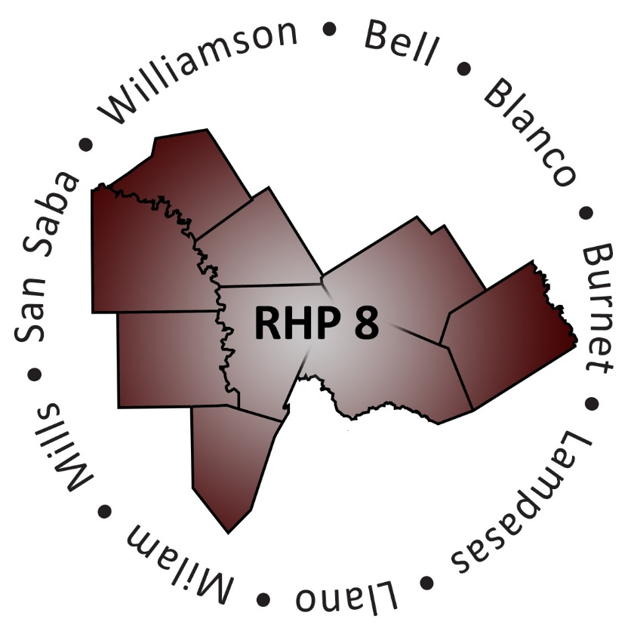
Learning Collaborative
Thursday, February 19, 2015 • 1:00 – 4:00 p.m.
Texas A&M Health Science Center – Auditorium
3950 North A.W. Grimes Boulevard, Round Rock, Texas 78665

Registration

Welcome, Purpose and Goals of the Event
RHP 8 Anchor Team

Welcome from the Texas A&M Health Science Center at Round Rock Campus
Dr. Jim Donovan, Vice Dean, Texas A&M Health Science Center
College of Medicine Round Rock Campus

Keynote Address
The Current State of Mental Health in Texas
Melissa Rowan, Healthcare Policy Director, Texas Council of Community Centers

Break

Children’s Panel
Panel Moderator: Andrea Richardson, Executive Director, Bluebonnet Trails Community Services

Panelists:
George DeReese, Assistant Chief Financial Officer, Little River Healthcare
Tiffany Gonzalez, LCSW, Clinical Director, Bluebonnet Trails Community Services
Kyle Johnson, MA, LMFTA, Skills Trainer T.I.S.D. Program, Central Counties Services

Patient Navigation Panel
Panel Moderator: Rita Kelley, Director, Bell County Indigent Health Services

Panelists:
Matt Boettcher, LMSW-AP, Vice President of Continuum of Care Services, Baylor Scott & White Health
Crissy Calvert, Project Coordinator 1115 Waiver, Seton Highland Lakes
Victoria Lippman, LBSW, Community and Social Services Director, Williamson County and Cities Health District

Update from RHP 8 Behavioral Health and Primary Care Cohort
Joey Smith, MBA, LPC, Director of Adult Mental Health Services, Center for Life Resources

Closing Remarks and Adjourn
RHP 8 Anchor Team

