Texas A&M University Health Science Center
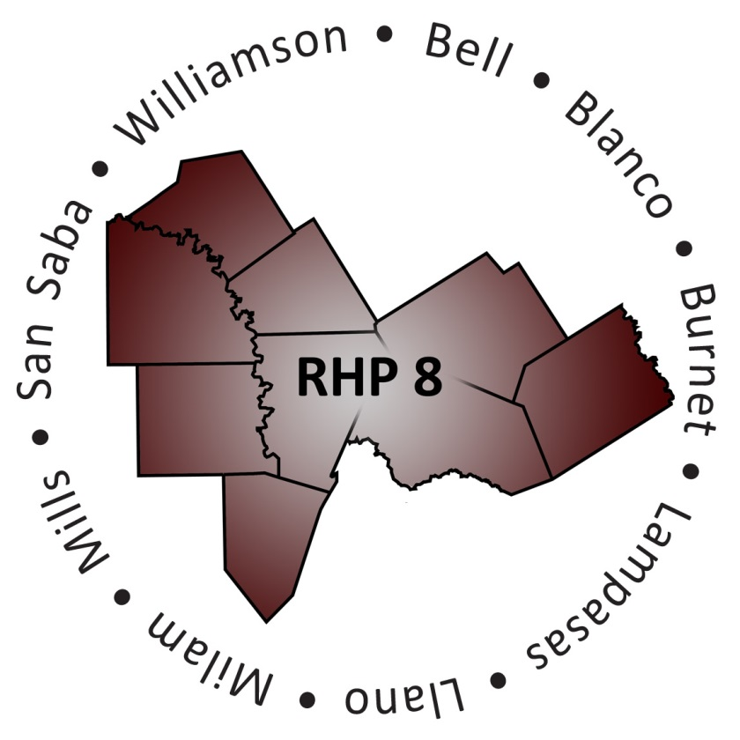
3950 A.W. Grimes Blvd., Round Rock, Texas 78665

Regional Healthcare Partnership 8
Learning Collaborative

Thursday, February 19, 2015
1:00-4:00 p.m.

Texas A&M Health Science Center
3950 North A.W. Grimes Boulevard
Round Rock, Texas 78665

AGENDA

Registration

Purpose and Goals of the Event
RHP 8 Anchor Team

Welcome Remarks from Texas A&M Health Science Center Round Rock Campus
Dr. Jim Donovan, Vice Dean, Texas A&M Health Science Center
College of Medicine Round Rock Campus

Keynote Address
The Current State of Mental Health in Texas
Melissa Rowan, Healthcare Policy Director, Texas Council of Community Centers

Children’s Panel
Panel Moderator: Andrea Richardson, Executive Director, Bluebonnet Trails Community Services

Panelists:
George DeReese, Assistant Chief Financial Officer, Little River Healthcare
Tiffany Gonzalez, LCSW, Clinical Director, Bluebonnet Trails Community Services
Kyle Johnson, MA, LMFT Associate, Skills Trainer T.I.S.D. Program, Central Counties Services

Patient Navigation Panel
Panel Moderator: Rita Kelley, Director, Bell County Indigent Health Services

Panelists:
Matt Boettcher, LMSW-AP, Vice President of Continuum of Care Services, Baylor Scott & White Health
Crissy Calvert, Project Coordinator 1115 Waiver, Seton Highland Lakes
Victoria Lippman, Community and Social Services Director, Williamson County and Cities Health District

Update from RHP 8 Behavioral Health and Primary Care Cohort
Joey Smith, MBA, LPC, Director of Adult Mental Health Services, Center for Life Resources

Closing Remarks
RHP 8 Anchor Team

Adjourn

Regional Healthcare Partnership 8 – Overview of Projects by Provider
Performing Provider Type: County Health District
Provider Name: Bell County Public Health District; County: Bell; IGT Entity: Bell County Public Health District
- 088334001.2.1 - Increase the availability of sexually transmitted disease (STD) testing at Health District clinics for male clients to ultimately decrease the possible harmful related outcomes associated with untreated infections.
- 088334001.2.2 - Increase the availability of STD testing at Health District clinics for female clients to ultimately decrease the possible harmful related outcomes associated with untreated infections.

Provider Name: Williamson County and Cities Health District; County: Williamson; IGT Entity: Williamson County and Cities Health District
- 126936702.1.1 - Expand capacity of access to preventive clinical care through availability of same day or next day appointments by increasing the level of healthcare professionals and extended hours at four local health clinics located in Cedar Park, Round Rock, Taylor, and Georgetown. This differs from the St. David’s Access2Care program which focuses on acute care for individuals under the 200% federal poverty line.
- 126936702.1.2 - Implement Community Paramedicine in rural communities which will increase access to proactive healthcare and decrease the overuse of emergency medical systems (EMS) for non-emergent events, leaving EMS to handle emergent needs.
- 126936702.1.3 - Enhance and improve the quality and consistency of public health REAL (race, ethnicity, gender, and language) client demographic data collection and interpretation to ensure health disparities are addressed appropriately.
- 126936702.2.1 - Provide navigation services to under/uninsured persons with targeted chronic conditions or pregnancy to prevent hospital admissions and readmissions.
- 126936702.2.2 - Use an interdisciplinary team to promote preventive health awareness by offering health education classes, eligibility assistance, and case management in the community, specifically for women of child bearing age, with a high incidence rate of frequent hospitalizations for chronic conditions, and/or in need of prenatal care.
- 126936702.2.100 - Implement innovative evidence-based strategies to reduce and prevent obesity in children and adolescents.

Performing Provider Type: Local Mental Health Authority
Provider Name: Bluebonnet Trails Community Center; Counties: Burnet and Williamson; IGT Entity: Bluebonnet Trails Community Center
- 126844305.1.1 - Provide outpatient behavioral health (BH) services to low-income persons in Taylor.
- 126844305.1.2 - Implement an involuntary 48-Hour Observation Emergency Detention Unit in Georgetown for the purpose of providing emergency and crisis stabilization services in a secure, protected, and clinically/psychiatrically supervised treatment environment.
- 126844305.1.3 - Implement a specialized Therapeutic Foster Care (TFC) program to help youth in crisis, diverting them from admission to hospitals or juvenile justice facilities.
- 126844305.1.4 - Provide crisis assessment, referral, and short-term stabilization in Burnet County (collaboration with Burnet County Sheriff's Department and Seton Highland Lakes Medical Center).126844305.1.5 - Establish outpatient substance abuse treatment sites in Georgetown, Marble Falls and Round Rock to meet the needs of a growing population, especially the poor, under/uninsured.
- 126844305.2.1 - Provide transitional housing in Williamson County for individuals needing BH services – persons staying in the houses are provided BH services to improve community living skills and transition into independent living.
- 126844305.2.2 - Utilize healthcare teams to reduce use of emergency services by individuals identified as high utilizers; those identified are offered proactive care in settings other than emergency departments (EDs) including their homes (collaboration with Williamson County Mobile Outreach and Community Paramedicine Teams).

- 126844305.2.3 - Provide intensive wrap around services (called Assertive Community Treatment (ACT)) for individuals with intellectual and developmental disabilities (IDD) at the point of crisis and during life transitions to prevent them from being placed in institutions or inappropriately using EDs and crisis services.
- 126844305.2.4 - Expand the clinical capacity and eligibility criteria for youth and adults arrested or incarcerated in Burnet and Williamson counties. Provide screening, assessment, and diversion recommendations prior to long-term incarceration; this includes linkage to community BH care.

Provider Name: Center for Life Resources; Counties: San Saba and Mills; IGT Entity: Center for Life Resources
- 133339505.1.1 - Implement telemedicine to provide clinically appropriate treatment as indicated by a psychiatrist or other qualified provider throughout Mills and San Saba counties. Thus, reducing unnecessary ED use, and improving consumer satisfaction/access were previously limited or unavailable.

Provider Name: Central Counties Services; Counties: Bell, Lampasas, and Milam; IGT Entity: Central Counties Services
- 081771001.1.1 - Provide school-based BH services for children, Kindergarten-5th grade, who have difficulty adjusting to the classroom environment due to emotional/behavioral problems. Counseling services may include the child’s family.
- 081771001.1.2 - Double telepsychiatry use from one full time employee (FTE) to two FTEs by enabling up to four simultaneous telepsychiatry/ telehealth users on a high quality telemedicine system.
- 081771001.1.3 - Implement group social skills training for persons diagnosed with high-functioning Autism or Asperger's disorder in Bell County.
- 081771001.1.4 - Provide 24/7 residential-based crisis respite (15 beds), transitional living (15 beds), and supportive day services at a properly equipped facility to persons with severe and persistent mental illness (SPMI) who have experienced a recent BH crisis, in lieu of being sent to the state psychiatric hospital system or incarcerated in local jails.
- 081771001.1.5 - Provide improved data management and organizational process improvement capacity allowing provider to focus on reducing readmissions to state psychiatric hospital and local jail by improving post discharge follow-up services. This project seeks to improve the efficiency of clinical service operations through improved technology and thus increase the provider’s capacity.
- 081771001.2.1 - Provide education, training, and support by a registered nurse (RN) for persons with SPMI having chronic health conditions due to prolonged psychiatric medicine use. The project builds the patient’s ability/desire to improve their self-managing of chronic health condition(s) instead of stopping psychotropic medications that helps their psychiatric symptoms.
- 081771001.2.2 - Provide adults and adolescents with SPMI easy access to STD education, testing, and treatment by a RN within the provider’s mental health clinics in Temple and Killeen, where patients already receive services.
- 081771001.2.3 - Provide supportive day services to adults with SPMI who were recently discharged from a psychiatric hospital or jail, or have recently experienced a crisis, putting them at risk for hospitalization/ incarceration.
- 081771001.1.100 - Provide work adjustment training to patients with high-functioning Autism or Asperger's disorder participating in project number 081771001.1.3 (social skills training) in Bell County.
- 081771001.2.100 - Provide trained law enforcement officers opportunity to assess the BH acuity of someone involved in a minor criminal event, and to direct that person into the BH service system instead of the criminal justice system.

Provider Name: Hill Country MHDD Centers; Counties: Blanco and Llano; IGT Entity: Hill Country MHDD Centers
- 133340307.2.1 - Implement co-occurring psychiatric and substance use disorder services (COPSD) in Blanco and Llano counties in order to meet the needs of individuals with psychiatric and substance use issues locally; thus, reducing ED utilization, impatient utilization, and incarceration.
- 133340307.2.2 - Implement trauma informed care services in Blanco and Llano counties to meet the need of individuals who experience trauma that is impacting their BH.
- 133340307.2.3 - Implement psychiatric and clinical guidance 24/7 for primary care physicians and hospitals in Blanco and Llano counties to help physicians identify and treat BH symptoms earlier to avoid exacerbation of symptoms into a BH crisis.
- 133340307.2.4 - Implement Whole Health Peer Support services in Blanco and Llano counties to meet the overall health needs of individuals who exhibit BH issues.
- 133340307.2.5 - Implement veteran mental health services in the Blanco and Llano counties to meet the overall health needs of veterans dealing with BH issues. Project expands current peer support services for veterans and their family members who need comprehensive, community-based, wrap-around BH services.

Performing Provider Type: Hospital
Provider Name: Baylor Scott & White – Llano; County: Llano; IGT Entity: Llano County
- 020840701.2.1 - Apply continuous process improvement (CQI) strategies guided by the Institute for Healthcare Improvement (IHI) Model to identify causes of avoidable EMS and ED utilization, prioritize potential solutions, and launch Plan, Do, Study, Act (PDSA) cycles on chosen improvements.
- 020840701.2.2 - Identify causes of avoidable Sheriff Department Transport of BH patients in crisis and prioritize potential ED and jail diversion solutions.

Provider Name: Baylor Scott & White – Memorial; County: Bell; IGT Entity: Bell County
- 137249208.2.1 - Provide patient navigation and selected chronic illness supports for a target group of people who are members/beneficiaries of the Bell County Indigent Care Program, Medicaid, and/or participating hospitals' charity care programs.

Provider Name: Seton Highland Lakes; County: Burnet; IGT Entity: Burnet County
- 094151004.2.1 - Implement a patient navigation system to connect indigent and uninsured patients to primary care or medical homes in order to reduce ED utilization and provide cost effective, timely, and site appropriate health care services. Patients are routed to a medical home by care navigators responsible for managing long-term relationships with patients to reduce their need for advanced medical care, including the ED.

Provider Name: Little River Healthcare; County: Milam; IGT Entity: Rockdale Hospital District
- 183086102.1.1 - Increase the number of Primary Care Physicians (PCPs) which will allow the hospital to increase clinic hours and provide earlier diagnosis of chronic and life-threatening diseases prior to the disease requiring an ED visit and urgent care; thus, enabling the ED to be used for true emergencies.
- 183086102.1.2 - Increase the access to Specialty Care Physicians (SCPs) by expanding the number of specialty providers and/or increasing clinic hours for the specialists most in demand. This will promote early diagnostic and screening services for at-risk patients including low income and uninsured individuals.

Provider Name: St. David’s Round Rock Medical Center; County: Williamson; IGT Entity: Williamson County
- 020957901.1.1 - Expand availability of primary care services to target the low income population in Williamson County that do not have existing health coverage by working with four existing local clinics to provide services: Sacred Heart, Good Samaritan, Lone Star Circle of Care – Taylor, and Bluebonnet Trails Community Services.

Provider Name: Seton Harker Heights; County: Bell; IGT Entity: Bell County
- 013122392.1.100 - Expand existing primary care capacity to provide patients with increased access to primary care services (preventive, primary, and chronic care) in Bell County by supporting the Greater Killeen Free Clinic.

UC-Only Hospitals:
Bell County:
- Cedar Crest Hospital
- Metroplex Health System
- Baylor Scott & White Clinic
Lampasas County:
- Rollins Brook Community Hospital
Williamson County:
- Cedar Park Regional
- Baylor Scott & White – Round Rock

RHP 8 Behavioral Health and Primary Care Cohort
What is the RHP 8 Behavioral Health and Primary Care Cohort (Cohort)?
The 1115 Waiver allows Providers to implement transformational projects across the State. The Cohort is a small team comprised of RHP 8 Providers and stakeholders who are actively implementing behavioral health and/or primary care projects, along with other community members who are interested in learning more about these projects.

What is the Cohort Purpose Statement?
The Cohort seeks opportunities to increase communication and promotes shared learning in RHP 8 with an overall focus on project sustainability.

Who Participates in the Cohort?
The Cohort is open to any interested stakeholder in RHP 8. Currently, the Cohort is comprised of individuals representing RHP 8 DSRIP and UC Providers (hospitals, local mental health authorities, and public health districts), other stakeholders in the community, two Co-Facilitators, and the Anchor team.

What if I Am Unable to Attend Meetings?
If you are not able to attend Cohort meetings but wish to learn about meeting happenings, the Anchor team archives meeting agendas and minutes on the RHP 8 website: http://www.tamhsc.edu/1115-waiver/rhp8/meetings/cohort.html/.

How Can I Learn More?
If you are interested in learning more about the Cohort contact the Co-Facilitators or the RHP 8 Anchor:
- Joey Smith, joey.smith@cflr.us
- Crissy Calvert, cmcalvert@seton.org
- RHP 8 Anchor, rhp8@tamhsc.edu
RHP 8 Quick Facts
RHP 8 Anchor: Texas A&M Health Science Center
RHP 8 Counties: Bell, Blanco, Burnet, Lampasas, Llano, Milam, Mills, San Saba, and Williamson
Anticipated Total Funding to Region: Approximately $214 million over 5 years (2011-2016)
Total Population in 9-county region: 860,963 (US Census, 2010)
Website: http://www.tamhsc.edu/1115-waiver/rhp8/index.html

Uncompensated Care (UC): Approximately $99 million
Federal Incentive: $58 million/IGT Local Funding: $41 million
Hospitals Participating in UC – 11
IGT Entities Supporting UC – 5
Hospitals Participating in UC-Only – 6
IGT Entities Supporting UC-Only – 2
Physician Groups Participating in UC – 1
IGT Entities Supporting Physician Groups UC – 1

Delivery System Reform Incentive Payment (DSRIP) Projects: Approximately $115 million
Federal Incentive: $67.4 million/IGT Local Funding: $47.6 million
Performing Providers – 12
IGT Entities Supporting DSRIP – 11
IGT Entities Supporting DSRIP-Only – 9

Overview of Projects
Category 1 and 2 – 41 (37 four-year projects; 4 three-year projects)
Category 3 (outcome measures) – 54
Category 4 (hospital only) – 6
Total Projects (all categories) – 101

Projects by Performing Provider (Category 1 and 2 Projects)
Bell County Public Health District | 2 | Scott & White Hospital - Llano | 2
Bluebonnet Trails | 9 | Scott & White Memorial Hospital | 1
Center for Life Resources | 1 | Seton Harker Heights | 1
Central Counties Services | 10 | Seton Highland Lakes | 1
Hill Country MHDD Centers | 5 | St David’s Round Rock Medical Center | 1
Little River Healthcare | 2 | Williamson County and Cities Health District | 6

Projects by Type (Category 1 and 2 Projects)
Behavioral Health Services | 16 | Chronic Care & Disease Management | 2
Primary Care Expansion | 5 | Performance/Process Improvement | 4
Specialty Care | 1 | Expand Capacity/Training Programs | 2
Health Promotion & Disease Prevention | 5 | Telemedicine | 3
Patient Care Navigation | 3

Brief Overview of Plan Submission/Approval Process
- Original RHP 8 Plan with four-year projects sent to HHSC December 2012 (HHSC to CMS February 2013)
    - Third region in the state out of 20 to submit a completed RHP Plan
    - Initial CMS approval/feedback - April 2013; final HHSC/CMS approval - December 2013
- New, three-year projects submitted to HHSC in December 2013
  - HHSC approval of three-year plans - February 2014; CMS approval of three-year plans - May 21, 2014

