Agenda
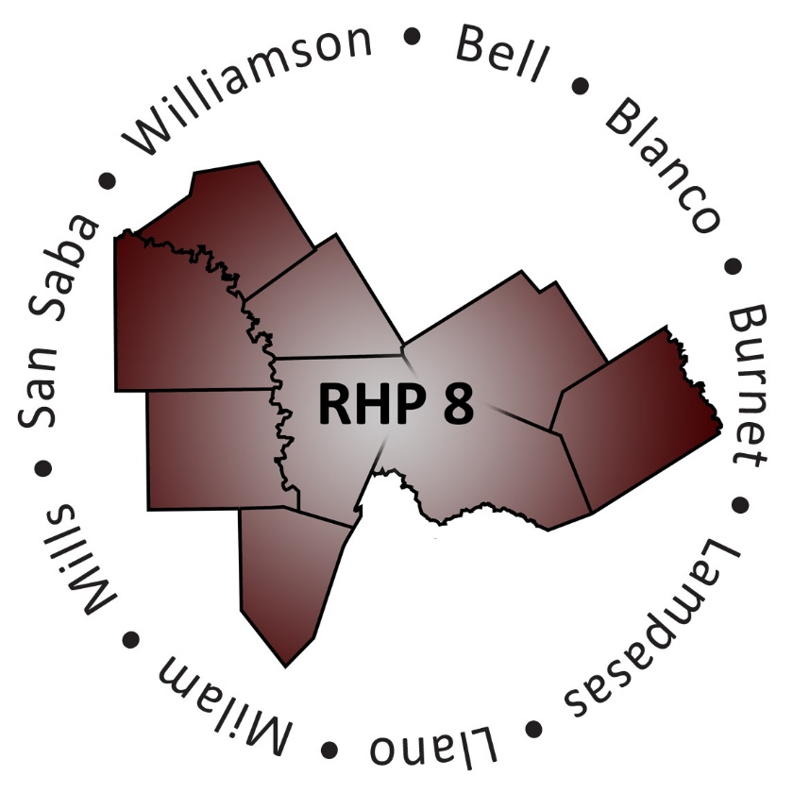
- Welcome and Introductions

- Review Meeting Minutes and Action Items from Last Meeting

Action Items – 12/03 Meeting
Person Assigned Task | Task | Status: Completed / Not Completed
Joey & Alexis | Type up & share meeting note with members | Completed
Joey & Alexis | Make “proof binders” for each member – will only make binders for persons who RSVP for next meeting
Joey | Research other hospitals on their prescription coverage right after discharge
Joey | Update Team Charter
Beth | Serve as “writer” for January Newsletter | Complete
Beth | Will look into HOGG Foundation
Crissy | Research Readmission Cohort
Crissy | Schedule and Plan Next Meeting | Complete
Crissy | Be the presenter on the Conference call | Complete
Jennifer | Update Cohort development materials and send to Joey and Alexis for “proof binders” | Complete

- Update from Cohort Members
During the December meeting Cohort members decided to focus on the following aim:
Identification of resources for payment of medication for indigent patients (specific focus is on the 7-10 day gap that occurs between receiving a prescription, and receipt of patient assistance program medications in the mail, even when applied for timely by the prescriber.)

- Members share information about “homework” findings (e.g., HOGG Foundation, what have other hospitals/clinics done to address this issue, are there any websites that compare prices/availability based on zip code)
- Participants decide on next steps/ideas about how to implement potential changes at their organization

- Next Steps/Adjourn Meeting (2:30-2:45)
- Decide on next Cohort meeting objectives and date
  - Different location?
  - Conference call or in-person?
- Review Action Items
- Adjourn

Action Items – 1/21 Meeting

Person Assigned Task | Task | Status: Completed/ Not Complete
 | Type up and share meeting notes with attendees
 | Schedule and organize next Cohort meeting

