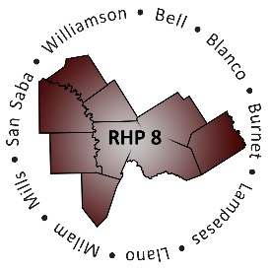
AGENDA

- Welcome/Introductions

- Review HHSC RHP Plan Update Templates
  - Updated Planning Timeline
  - Template Overview and Reminders

- Category A (Core Activity) Requirements and Driver Diagrams
  - Category A Requirements
  - Driving Diagrams for DSRIP

- Open Workgroup/Questions and Answer
  - Driver Diagram Worksheets
  - General Plan Template Questions

- Wrap-Up/Adjourn

