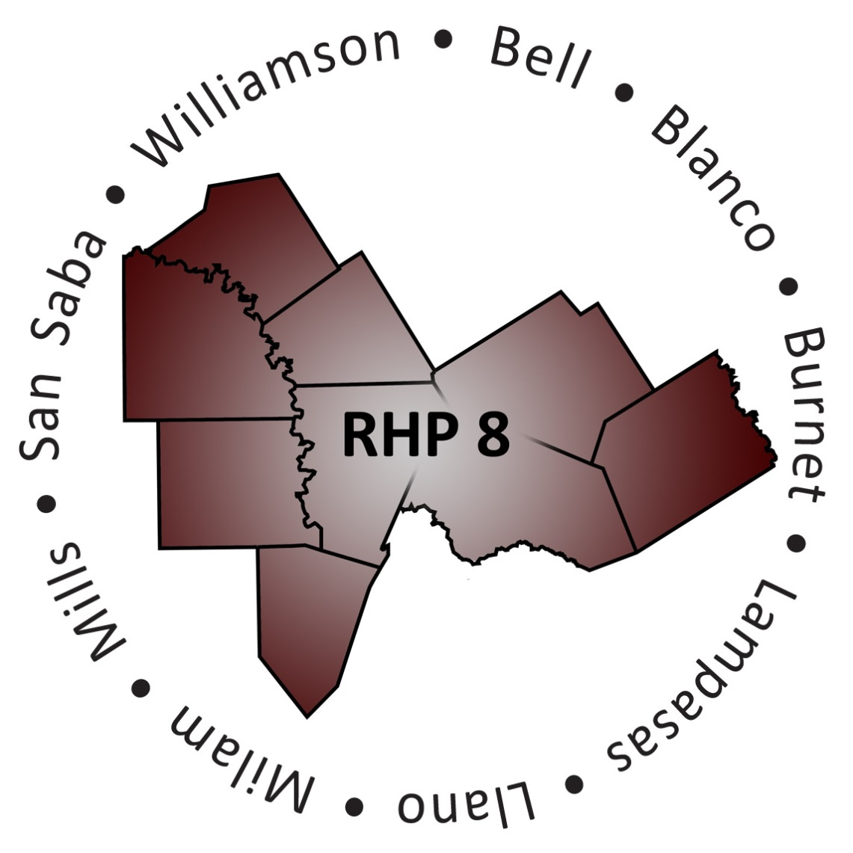

Texas Regional Healthcare Partnership (RHP) 8
Plan, Do, Study, Act (PDSA) Guide

Table of Contents
Contents
What is Continuous Quality Improvement? 3
Plan, Do, Study, Act (PDSA) Model for Improvement 3
Questions to Guide Improvement 4
PDSA Worksheet 4
PDSA Worksheet for Testing Change 5
PDSA Directions and Examples 6
How to Complete the PDSA Worksheet 7
Examples of Completed PDSA Worksheets 8

What is Continuous Quality Improvement?

The Centers for Medicare and Medicaid Services (CMS) hosted a webinar for Anchor teams to attend in the fall of 2013. During this webinar the Institute for Healthcare Improvement (IHI) ‘Breakthrough Series’ framework was highlighted as a model Providers may want to use to measure continuous quality improvement (CQI).

Plan, Do, Study, Act (PDSA) Model for Improvement
Out of the ‘Breakthrough Series’ presentation many Providers began implementing the Plan, Do, Study, Act (PDSA) model as their tool to measure CQI. PDSA is used to drive continuous improvement. Plan it, try it, observe the results, and act on what is learned, and it is the scientific method adapted for action-oriented learning– hence the cycle imagery.

The basic premise of the PDSA is to test changes on a small scale, learn from each small-scale pilot test, refine the change through several PDSA cycles, then implement on a broader scale. After successful implementation of a change, or group of changes for a pilot population, the changes should be communicated and shared with others. Although the majority of Providers are choosing to implement and manage the PDSA model in their organizations, there are a handful of Providers implementing ‘Other’ internal process improvement systems to capture CQI as related to their DSRIP project(s).

Questions to Guide Improvement
The PDSA model can be broken down into four simple steps that any group can manage:
Step 1
Cohort team members will ask the key questions that will in turn drive CQI efforts of the cohort:
- What are we trying to accomplish?
- How will we know that a change is an improvement?
- What changes can we make that will result in improvement?
Step 2
The cohort participants will be charged with going back to their respective organizations use the PDSA model and implementing new changes for a short period of time (known as an ‘action period’).
Step 3
Participants of the cohort will regroup, share with the cohort participants how the changes impacted their organization, and the cohort will share those findings with region stakeholders.
Step 4
The cohort will reassess what went well and what areas may have room for improvement, and then the cohort will reformulate their PDSA cycle by beginning with step 1.

PDSA Worksheet
The PDSA Worksheet is a useful tool for documenting a test of change. This worksheet is used in the IHI’s "Methods and Tools for Breakthrough Improvement" course, the PDSA Worksheet has been used by hundreds of health care organizations.

Cohort participants should use the PDSA worksheet to help the cohort document a test of change. Complete out one PDSA worksheet for each test conducted. The cohort team should test several different changes, and each change will go through several PDSA cycles. The Anchor team encourages participants keep a file (either electronic or hard copy) of all PDSA worksheets – these should be included as part of the semi-annual reporting process to the Texas Health and Human Services Commission (HHSC).

The following page offers an example of PDSA worksheet cohort participants might find useful – this worksheet may be found on the IHI website at this link: http://www.ihi.org/resources/pages/tools/plandostudyactworksheet.aspx

An example of a completed PDSA cycle template may be found on The SAMHSA-HRSA Center for Integrated Health Solutions (CIHS) website at this link: http://www.integration.samhsa.gov/pbhci-learning-community/PDSA.pdf

PDSA Worksheet for Testing Change

Aim: (overall goal cohort participant wishes to achieve)
___________________________________________________________________________________________________________________________________
___________________________________________________________________________________________________________________________________

Each goal will require multiple smaller tests of change:
Describe your first (or next) test of change: | Person responsible: | When to be done: | Where to be done:

Plan - List the tasks needed to set up this test of change and predict what will happen when the test is carried out:
List the tasks needed to set up this test of change: | Person responsible: | When to be done: | Where to be done:

Predict what will happen when the test is carried out: | Measures to determine if prediction succeeds:

Do - Describe what happened when you ran the test:
___________________________________________________________________________________________________________________________________
___________________________________________________________________________________________________________________________________

Study - Describe the measured results and how they compared to the predictions:
___________________________________________________________________________________________________________________________________
___________________________________________________________________________________________________________________________________

Act - Describe what modifications to the plan will be made for the next PDSA cycle from what was learned:
___________________________________________________________________________________________________________________________________
________________________________________________________________________________________________________________________________

PDSA Directions and Examples
The Plan-Do-Study-Act method is a way to test a change that is implemented. By going through the prescribed four steps, it guides the thinking process into breaking down the task into steps and then evaluating the outcome, improving on it, and testing again. Most of us go through some or all of these steps when we implement change in our lives, and we don’t even think about it. Having them written down often helps people focus and learn more.
Keep the following in mind when using the PDSA cycles to implement the health literacy tools:
- Single Step - Each PDSA often contains only a segment or single step of the entire tool implementation.
- Short Duration - Each PDSA cycle should be as brief as possible for you to gain knowledge that it is working or not (some can be as short as 1 hour).
- Small Sample Size - A PDSA will likely involve only a portion of the practice (maybe 1 or 2 doctors). Once that feedback is obtained and the process refined, the implementation can be broadened to include the whole practice.
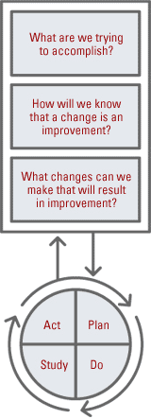

For more information on the Plan-Do-Study-Act, go to the IHI (Institute for Healthcare Improvement) Web site or view this PowerPoint presentation on Model for Improvement.

How to Complete the PDSA Worksheet
Tool: Fill in the tool name you are implementing.
Step: Fill in the smaller step within that tool you are trying to implement.
Cycle: Fill in the cycle number of this PDSA. As you work though a strategy for implementation, you will often go back and adjust something and want to test if the change you made is better or not. Each time you make an adjustment and test it again, you will do another cycle.
PLAN
I plan to: Here you will write a concise statement of what you plan to do in this testing. This will be much more focused and smaller than the implementation of the tool. It will be a small portion of the implementation of the tool.
I hope this produces: Here you can put a measurement or an outcome that you hope to achieve. You may have quantitative data like a certain number of doctors performed teach-back, or qualitative data such as nurses noticed less congestion in the lobby.
Steps to execute: Here is where you will write the steps that you are going to take in this cycle. You will want to include the following:
- The population you are working with – are you going to study the doctors’ behavior or the patients’ or the nurses’?
- The time limit that you are going to do this study – remember, it does not have to be long, just long enough to get your results. And, you may set a time limit of 1 week but find out after 4 hours that it doesn’t work. You can terminate the cycle at that point because you got your results.
DO
After you have your plan, you will execute it or set it in motion. During this implementation, you will be keen to watch what happens once you do this.
What did you observe? Here you will write down observations you have during your implementation. This may include how the patients react, how the doctors react, how the nurses react, how it fit in with your system or flow of the patient visit. You will ask, “Did everything go as planned?” “Did I have to modify the plan?”
STUDY
After implementation you will study the results.
What did you learn? Did you meet your measurement goal? Here you will record how well it worked, if you meet your goal.
ACT
What did you conclude from this cycle? Here you will write what you came away with for this implementation, if it worked or not. And if it did not work, what can you do differently in your next cycle to address that. If it did work, are you ready to spread it across your entire practice?

Examples of Completed PDSA Worksheets
Two examples of how to fill out the PDSA worksheet for two different tools, Tool 1 – Patient Feedback (pages 19-21): and Tool 2 -Teach-Back Method (pages 22-24). Each of the two tools contain three PDSA cycles. Each tool has short cycles and works through a different option on how to disseminate the survey to patient (Tool 1 - Patient Feedback) and how to introduce teach-back and have Providers try it (Tool 2- Teach-Back Method).
PDSA (plan-do-study-act) worksheet
TOOL: Tool 1 - Patient Feedback STEP: Dissemination of surveys CYCLE: 1st Try
PLAN
I plan to: We are going to test a process of giving out satisfaction surveys and getting them filled out and back to us.
I hope this produces: We hope to get at least 25 completed surveys per week during this campaign.
Steps to execute:
- We will display the surveys at the checkout desk.
- The checkout attendant will encourage the patient to fill out a survey and put it in the box next to the surveys.
- We will try this for 1 week.

DO
What did you observe?
- We noticed that patients often had other things to attend to at this time, like making an appointment or paying for services and did not feel they could take on another task at this time.
- The checkout area can get busy and backed up at times.
- The checkout attendant often remembered to ask the patient if they would like to fill out a survey.

STUDY
What did you learn? Did you meet your measurement goal?
We only had 8 surveys returned at the end of the week. This process did not work well.

ACT
What did you conclude from this cycle?
Patients did not want to stay to fill out the survey once their visit was over. We need to give patients a way to fill out the survey when they have time.
We will encourage them to fill it out when they get home and offer a stamped envelope to mail the survey back to us.
PDSA (plan-do-study-act) worksheet
TOOL: Tool 1 - Patient Feedback STEP: Dissemination of surveys CYCLE: 2nd Try
PLAN
I plan to: We are going to test a process of giving out satisfaction surveys and getting them filled out and back to us.
I hope this produces: We hope to get at least 25 completed surveys per week during this campaign.
Steps to execute:
- We will display the surveys at the checkout desk.
- The checkout attendant will encourage the patient to take a survey and an envelope. They will be asked to fill the survey out at home and mail it back to us.
- We will try this for 2 weeks.

DO
What did you observe?
- The checkout attendant successfully worked the request of the survey into the checkout procedure.
- We noticed that the patient had other papers to manage at this time as well.
- Per Checkout attendant only about 30% actually took a survey and envelope.

STUDY
What did you learn? Did you meet your measurement goal?
We only had 3 surveys returned at the end of 2 weeks. This process did not work well.

ACT
What did you conclude from this cycle?
Some patients did not want to be bothered at this point in the visit – they were more interested in getting checked out and on their way.
Once the patient steps out of the building they will likely not remember to do the survey.
We need to approach them at a different point in their visit when they are still with us – maybe at a point where they are waiting for the doctor and have nothing to do.
PDSA (plan-do-study-act) worksheet
TOOL: Tool 1 - Patient Feedback STEP: Dissemination of surveys CYCLE: 3rd Try
PLAN
I plan to: We are going to test a process of giving out satisfaction surveys and getting them filled out and back to us.
I hope this produces: We hope to get at least 25 completed surveys per week during this campaign.
Steps to execute:
- We will leave the surveys in the exam room next to a survey box with pens/pencils.
- We will ask the nurse to point the surveys out/hand then out after vitals and suggest that while they are waiting they could fill out our survey and put it in box.
- We will see after 1 week how many surveys we collected.

DO
What did you observe?
- Upon self report, most nurses reported they were good with pointing out or handing the patient the survey.
- Some patients may require help reading the survey, but nurses are too busy to help.
- On a few occasions the doctor came in while patient filling out survey so survey was not complete.

STUDY
What did you learn? Did you meet your measurement goal?
We had 24 surveys in the boxes at the end of 1 week. This process worked better.

ACT
What did you conclude from this cycle?
Approaching patients while they are still in the clinic was more successful.
Most patients had time while waiting for the doctor to fill out the survey.
We need to figure out how to help people who may need help reading the survey.
PDSA (plan-do-study-act) worksheet
TOOL: Tool 2 - Teach-Back Method STEP: MDs initially performing Teach-back CYCLE: 1st Try
PLAN
I plan to: We will ask the physicians in Wednesday PM to perform teach-back with the last person they see that day.
I hope this produces: We hope that all the physicians will perform teach-back and find that it was useful, did not take that much more time, and they will continue the practice.
Steps to execute:
- We will ask the 5 physicians who hold clinic on Wednesday PM to perform teach-back with their last patient of the day.
- We will show these physicians the teach-back video.
- After their last patient checks out, we will ask the physicians if they felt
  - It was useful?
  - It was time consuming?
  - They will do it again?

DO
What did you observe?
All physicians found the teach-back video informative and seemed eager to try this new tool.

STUDY
What did you learn? Did you meet your measurement goal?
4 out of 5 physicians performed teach-back on at least one patient in the afternoon. The 1 physician who did not indicated she did not quite know how to integrate it into her visit.

ACT
What did you conclude from this cycle?
4 out of 5 felt comfortable with it and said they would continue using it.
For the 1 who was not sure how to integrate it, we will look for other teach-back resources to help address this.
PDSA (plan-do-study-act) worksheet
TOOL: Tool 2 - Teach-Back Method STEP: MDs continuing to perform Teach-back CYCLE: 2nd Try
PLAN
I plan to: We will see if the physicians in Wednesday PM clinic are still performing teach-back by asking them after their last patient leaves. (3 weeks have gone by since initial introduction.)
I hope this produces: We hope that each of the physicians will have performed teach-back on at least 3 of their afternoon patients.
Steps to execute:
- We will approach the 5 physicians on Wednesday PM after their last patient leaves and ask them to count the number of patients they performed teach-back on this afternoon.
- We will ask the physicians if they still feel
- It was useful?
- It was time consuming?
- They will do it again?
DO
What did you observe?
Some physicians could not find appropriate situations for teach-back.
All still felt it was a worthy tool during their patient visits but feel they need to remember it and practice it more.

STUDY
What did you learn? Did you meet your measurement goal?
3 out of 5 physicians said they did perform teach-back on 3 of their patients.
1 performed it in one instance.
1 did not perform it at all (same one as before).

ACT
What did you conclude from this cycle?
Teach-back is being used, maybe not as readily as I had anticipated.
Maybe the goals of ‘3 out of 6 patient encounters should contain teach-back’ is unrealistic. We may put a sign in the clinic rooms, in view of the physicians, to remind them about teach-back; will measure again in 6 months.
PDSA (plan-do-study-act) worksheet
TOOL: Tool 2 - Teach-Back Method STEP: MDs continuing performing Teach-back CYCLE: 3rd Try
PLAN
I plan to: We want to see if the signs put up in the exam rooms help physicians remember to do teach-back and increased its utilization.
I hope this produces: We hope that all the physicians will perform teach-back 3 out of 6 times.
Steps to execute:
- We will put signs reading “Teach it Back” taped on the exam room desk/work area to remind physicians to use the technique.
- We will ask physicians if they notice the signs and if they reminded them to perform teach-back.
- We will see if Wednesday PM clinic had increased use of teach-back.

DO
What did you observe?
Nurses felt the sign will get in the way.

STUDY
What did you learn? Did you meet your measurement goal?
4 out of 5 physicians did teach-back on 3 patients Wednesday afternoon. 1 did it on 1 patient.
4 out of 5 said they did see the sign and that it was a reminder to do teach-back.

ACT
What did you conclude from this cycle?
A reminder is needed (especially initially) to help physicians use this tool in their visit.
No further intervention needed at this point.

