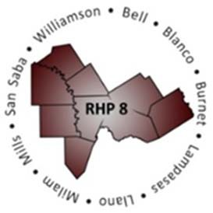
Regional Healthcare Partnership 8 and 17

Joint Monthly Learning Collaborative Call & Cohort via WebEx
Thursday, November 10, 2016 • 10:00 – 11:30 a.m.

WebEx Link: Join WebEx Meeting Meeting Number: 925 059 147

Conference Line: 877-931-8150
Participant Code: 3621413

Agenda

- Welcome and Introductions/Roll Call

- Raise Performance – Category 3 Review with Examples
  - Review Category 3 development and components – P4P, P4R, and Alternate Improvement Activities
  - Review Category 3 reporting periods – Performance Years versus Demonstration Years
  - Review Category 3 measure specifications – Using the compendium to report to specifications

- Cohort Discussion: Provider experiences with reporting Category 3 and data analysis. Share lessons learned through compliance monitoring and/or internal re-evaluation of data. Share challenges with the group and successes.

Recommended Next Steps
  - Compendium review
  - Data double-check
  - Recalculation (if needed)
  - Correction (if needed)

Upcoming Events & Adjourn
  - No formal LC call or cohort meeting due to holidays and regional meetings.
  - 12/7/16 – RHP 8 Regional Meeting in Round Rock
  - 12/8/16 – RHP 17 Regional Meeting in Bryan/College Station
  - 12/9/16 – HHSC to release reporting review and NMI period opens
  - 12/26/16 thru 12/30/16 – TAMHSC Holiday Break; Anchor offices closed
  - 1/19/16 – Joint Cohort Meeting (Round Rock): Managed Care Roundtable with United Healthcare

Have an idea/suggestion to share or topic to recommend for future Learning Collaborative calls, articles, or upcoming events? We want to know! Email the Anchor Teams at TAMHSC-1115-Anchor-Team@tamhsc.edu

