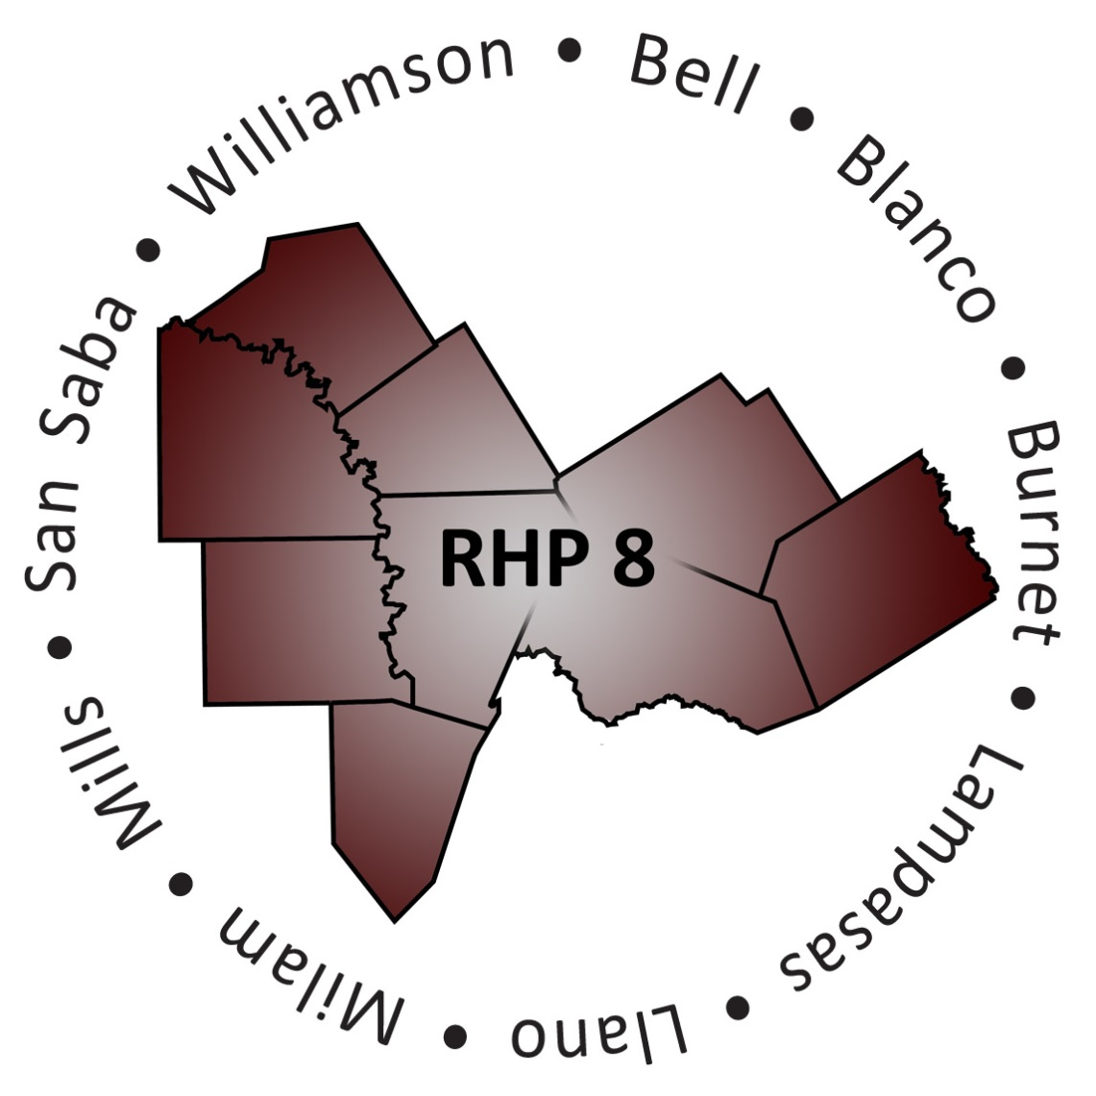

Texas Regional Healthcare Partnership (RHP) 8
Behavioral Health and Primary Care Cohort
December 2014

Table of Contents
Contents
Summary of Activities/Proposed Timeline 3
RHP 8 Learning Collaborative 4
Background & Overview of Learning Collaborative 4
Structure 4
RHP 8 Behavioral Health & Primary Care Cohort 6
Overview 6
Background 6
Structure 8
Roles 8
Information and Resources 9
Appendix A – Proposed RHP 8 Learning Collaborative Structure 10

Summary of Activities/Proposed Timeline
Learning Collaborative and Cohort Schedule – Meeting Dates and Other Important Events
Date | Event
April 2 | First RHP 8 Face-to-Face Meeting for Demonstration Year 3 hosted and facilitated by Anchor team at Texas A&M Health Science Center, Round Rock –  “RHP 8 Learning Collaborative Kick-Off”
Early-June | Cohort team development begins with RHP 8 Behavioral Health/Primary Care Cohort team
July 1 | First learning collaborative webinar event hosted by RHP 8 & RHP 17 –  “Six Sigma”
July 31 | First Cohort meeting is hosted to establish team and discuss goals, aims, and team charter
August 20 | Second RHP 8 Face-to-Face Meeting for Demonstration Year 3 hosted and facilitated by Anchor team at Georgetown Chamber of Commerce –  “Big Data, Big Health”
September 9-10 | HHSC hosted State Learning Collaborative in Austin
October 31 | October DY3 report is due (reporting period: October 1, 2013 – September 30, 2014)

RHP 8 Learning Collaborative

Background & Overview of Learning Collaborative
Many projects in RHP 8 test inventive models of care that move away from historical systems of treatment and toward a more integrated and coordinated approach. These inventive models focus on the patient’s whole-person needs and health outcomes. As RHP 8’s Performing Providers implement advances it is important they learn from others successes and challenges, as well as identify best practices that can be widely implemented.

The DSRIP Transformative piece of the 1115 Medicaid Waiver encourages bringing together the various Performing Providers in the RHP to learn from each other and improve their clinical practices through continuous quality improvement (CQI).

The RHP 8 Learning Collaborative is made up of interested stakeholders, and it allows Providers in the region to join together to implement CQI activities, such as the Institute for Healthcare Improvement (IHI) Model for Improvement through smaller segmented groups known as ‘Cohorts’.

Structure
RHP 8 is a Tier 4 region that is smaller and more rural than most of the regions in the State. Implementation of a Learning Collaborative to the degree outlined in Appendix A of the RHP Planning Protocol presents a significant administrative burden to adequately employ. However, while RHP 8 has the option to opt out of doing a Learning Collaborative, the Anchor team fully supports the goals of the 1115 Waiver and feels there is benefit to the region at large in coming together for activities designed to foster stakeholder collaboration and dialogue geared toward learning and CQI.

To that end, RHP 8 has proposed to manage a 'hybrid' Learning Collaborative model which incorporates components of the IHI model recommendations, while facilitating opportunities both inside- and outside-RHP 8, for stakeholder participation without being too burdensome (for a visual outlining the proposed RHP 8 Learning Collaborative Model, see Appendix A).

The ‘hybrid’ Learning Collaborative model proposed by RHP 8 to the Texas Health and Human Services Commission (HHSC) and Centers for Medicare and Medicaid Service (CMS) in the fall of 2013 was a compromise between a full-blown Learning Collaborative that would prove too burdensome, and the unengaged alternate options for Tier 4 regions. This approach not only includes participation in the statewide collaborative and securing opportunities for RHP 8 Providers to participate in the larger RHP Learning Collaboratives (if desired), but also involves deployment of a joint Learning Collaborative model within RHP 8 and RHP 17.

While RHP 8 has unique Providers, systems, and community needs driving that region, both RHP 8 and 17 are Tier 4 regions that are geographically similar, and both are anchored by the Texas A&M Health Science Center. This lends itself to meaningful collaboration for learning between the two regions and relative ease of communication through networked videoconferencing for shared activities to include speakers, highlighted projects, and exploration of potential topic areas in DYs 4 and 5.

Learning Collaborative membership will be open to all interested stakeholders in the region. However, the Anchor team anticipates membership to primarily consist of those providing current services and/or implementing new services - project leads and representatives from RHP 8’s, 12 Performing Providers, as well as subcontractors and community partners who may be working with them.

The RHP 8 Learning Collaborative model is comprised of three major areas which ultimately feed into one another: people, actions, and output.
The comprised of three main areas:
- People: Participants are the foundation of the Cohort. Without involvement from regional stakeholders, there would be no team to share ideas amongst Providers. Participants are needed as volunteers to lead and facilitate the group. Participants will be Providers and non-Providers.
- Actions: The key areas to be addressed by the Cohort are to define aim(s), establish measures(s), and select changes to test. The Cohort volunteer lead will guide the group on these discussions and document the Cohort’s aims, measures, and outcomes.
- Output: Without measuring the impact of the actions taken by the group, there would be no shared learning. People in the Cohort must track measures and share their findings on the actions they implemented. Additionally, the Cohort must identify and share findings with the regional stakeholders at region-wide learning opportunities.

RHP 8 Behavioral Health & Primary Care Cohort

Overview
Smaller, more segmented groups of individuals who are part of the Learning Collaborative have an opportunity to be part of RHP 8’s Behavioral Health and Primary Care Learning Collaborative Cohort (also known throughout this document as the ‘Cohort’). The Cohort will focus on:
1. Sharing knowledge and expertise;
2. Improving patient and care-giver experience; and
3. Implementing evidence-based guidelines.

The purpose for the Cohort is to create an area of regional focus and to bring together stakeholders with similar projects, goals, and interests for focused CQI activities and collaboration. Additionally, the Cohort should promote efficiencies and improve health care delivery and access throughout the region.

Background
The RHP 8 Anchor team adapted a collaborative survey tool shared with us by RHP 2, and sent that out to RHP 8 stakeholders both in September 2013 and again in March 2014. Based on responses received by RHP 8 stakeholders the majority indicated interest in focusing their findings on more qualitative areas: e.g., increased community/patient engagement, how other Providers are implementing/incorporating DSRIP projects into their existing structures, etc.

After the collaborative survey results were reviewed by the Anchor team, the team reviewed needs as identified in the Community Needs Assessment table of the RHP 8 plan submitted to HHSC and CMS in February 2013.

The Anchor team studied the types of projects in the region (by Provider and by Type) and the team selected to focus and develop one Cohort in the region that would satisfy the desires and wants of the majority of stakeholders in RHP 8: Behavioral Health & Primary Care.

Overview of RHP 8 Projects (Category 1 & 2) by Provider Name
Provider Name | Number of Cat 1/2 Projects
Bell County Public Health District | 2
Bluebonnet Trails Community Center | 9
Center for Life Resources | 1
Central Counties Services | 10
Hill Country MHDD Centers | 5
Little River Healthcare | 2
Scott & White Hospital - Llano | 2
Scott & White Memorial Hospital | 1
Seton Harker Heights | 1
Seton Highland Lakes | 1
St David’s Round Rock Medical Center | 1
Williamson County and Cities Health District | 6

Overview of RHP 8 Projects (Category 1 & 2) by Provider Type
Project Type | Number of Cat 1/2 Projects
Behavioral Health Services | 16
Primary Care Expansion | 5
Specialty Care | 1
Health Promotion & Disease Prevention | 5
Patient Care Navigation | 3
Chronic Care & Disease Management | 2
Performance/Process Improvement | 4
Expand Capacity/Training Programs | 2
Telemedicine | 3

On April 2, 2014, the Anchor team hosted the first face-to-face ‘RHP 8 Learning Collaborative Kick-Off Event’ meeting. Stakeholders were present from across the region. The Anchor team reviewed with participants the details of the RHP 8 Learning Collaborative structure, and two subject matter experts (SMEs) presented to the group.

Structure
The Cohort will bring together participants from different organizations that will implement and review findings of various CQI methods that focus on Provider-specific challenges. Participants will then group together and discuss findings after the short spurt of piloting the changes (typically three-four weeks). At that point, participants will talk about what happened when they implemented the changes in their organizations. Cohort participants will be expected to share their findings with stakeholders in the region via the RHP 8 conference call and the RHP 8 monthly newsletter.

At each Cohort meeting participants will review new information and its relevance to their project(s); encourage discussion around progress toward goals; discuss lessons learned; and review successes, challenges, and identification of best practices.

Subject matter experts (SMEs) from the community (both from within and outside the Performing Provider organizations; e.g., clinical staff from a private hospital, faculty from a higher education institution, etc.) will be invited to attend the Cohort events and spread their knowledge with those in attendance.

The RHP 8 Anchor team encourages open and broad stakeholder participation. Although participation in the Cohort is not mandatory, it is strongly encouraged and stakeholders may join at any point during the life of the Waiver.

Roles
The numbers of defined roles for the Collaborative are minimal at this time, and the Anchor team expects them to expand and become more defined as the Cohort matures:
- RHP 8 Anchor Team – offers guidance to and Co-Facilitators on Cohort topics; shares information with Co-Facilitators from HHSC that may affect the Cohort; provides a conference call line for Co-Facilitators to use when planning and scheduling a Cohort meeting; attends Cohort meetings; updates RHP 8 monthly newsletter with update from Cohort team
- RHP 8 Behavioral Health & Primary Care Cohort Co-Facilitators – organizes meeting dates and times; drafts and disseminates meeting materials to Cohort participants prior to meetings; follows-up and provides meeting minutes to Cohort participants after meetings; communicate and share findings of Cohort with RHP 8 stakeholders via a conference call (this may be delegated to various Cohort members so the same person is not presenting on each call); identifies and invites subject matter experts (SMEs) to be a part of Cohort meetings (as needed)
- RHP 8 Behavioral Health & Primary Care Cohort Participant – shares data as developed from group activities and/or general project implementation to help identify and document challenges, lessons learned, successes, etc., for both continuous quality improvement and regional reporting; engages in group discussion and is a contributing member of the Cohort; collaborates in on-going development of the Cohort; provides updates to the RHP 8 Behavioral Health & Primary Care Cohort Co-Facilitators as requested

Information and Resources
The Anchor team strives to provide ample opportunities for continued growth for regional stakeholders.
Some of the opportunities the Anchor team will assist in providing to Cohort participants include:

Monthly Newsletter
A monthly newsletter is sent out to stakeholders and it includes the following areas: Anchor updates, opportunities to participate in RHP 8 Learning Collaborative activities; project spotlights on innovative agents; project celebrations and success stories; and learning links (webinars, white papers, relevant articles related to healthcare). The current monthly newsletter (along with archived copies) is available on the RHP 8 website in the Learning Collaborative section at this link:
http://www.tamhsc.edu/1115-waiver/rhp8/lc/newsletter.html

Conference Calls with RHP 8 Stakeholders
These calls are hosted and facilitated by the Anchor team. The RHP 8 Anchor team initiated conference calls in demonstration year 3; this allowed for Providers to get their projects through the planning stage and into the implementation stage. The conference calls allow RHP 8 stakeholders to share CQI activity updates, present success stories, describe and provide solutions on challenges faced, and disseminate best practices amongst one another. The conference call meeting minutes are available on the RHP 8 website in the Learning Collaborative section at this link:
http://www.tamhsc.edu/1115-waiver/rhp8/lc/calls.html

Website and Discussion Forum
The RHP 8 Learning Collaborative website was developed by the RHP 8 Anchor team along with a distribution listserv (known as the RHP 8 Learning Collaborative Discussion Forum) to be utilized by stakeholders to communication with one another.

The RHP 8 website offers stakeholders an opportunity to explore the following areas: regional timeline, access to the 4-year project and 3-year project plans, community needs information, previous meeting materials, Learning Collaborative events and materials, and access to helpful documents from HHSC. The RHP 8 website is available at this link:
http://www.tamhsc.edu/1115-waiver/rhp8/index.html

The RHP 8 Learning Collaborative Discussion Forum was created in the spring of 2014, it is a listserve that allows stakeholders to share of ideas, challenges, and lessons learned throughout project implementations. Information about how to join the RHP 8 Learning Collaborative Discussion Forum is available on the RHP 8 website at this link:
http://www.tamhsc.edu/1115-waiver/rhp8/lc/forum.html

Face-to-Face Regional Meetings
In addition to conference calls, disseminating information in the website and through the discussion forum, information sharing will also take place at the large regional face-to-face meetings that will occur at least twice a year.

Appendix A – Proposed RHP 8 Learning Collaborative Structure

