Regional Healthcare Partnership 8
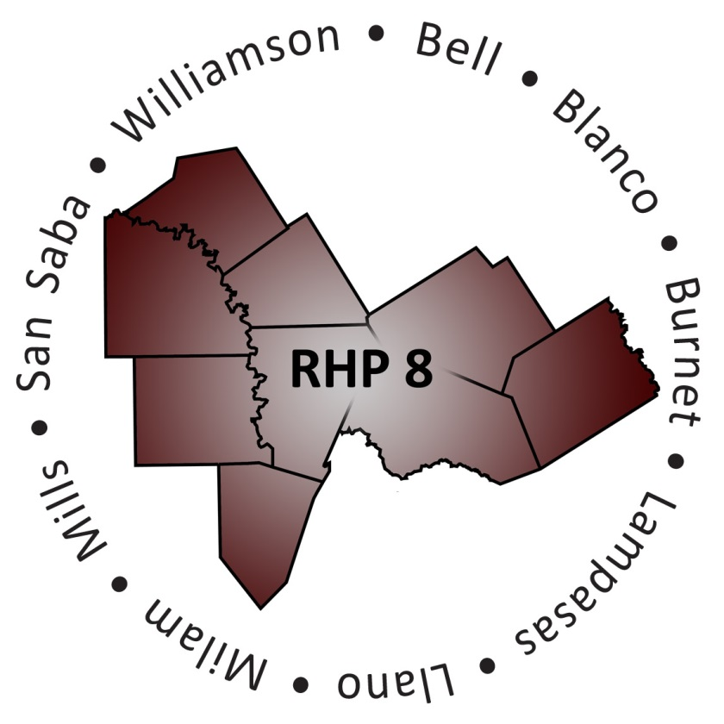
Overview of the RHP 8 Behavioral Health and Primary Care Cohort

What is the RHP 8 Behavioral Health and Primary Care Cohort (“Cohort”)?
The 1115 Waiver allows for Providers to implement transformational projects across the State. The Cohort is a small team comprised of RHP 8 stakeholders who are actively implementing behavioral health and/or primary care projects, along with other community members who are interested in learning more about these projects.

What is the Cohort Purpose Statement?
The Cohort will seek opportunities to increase communication and promote shared learning in RHP 8 with an overall focus on project sustainability.

Who Participates in the Cohort?
The Cohort is open to any interested stakeholder in RHP 8. Currently, the Cohort is comprised of individuals representing RHP 8 DSRIP and UC Providers (hospitals, local mental health authorities, public health districts, and emergency medical services), other healthcare stakeholders in the community, two co-facilitators, and the Anchor team.

How Can I Learn More?
If you are interested in learning more about the Cohort contact the RHP 8 Anchor team.

Who are the Cohort Co-Facilitators?
Meghan Nadolski
Project Coordinator, 1115 Medicaid Waiver
Bluebonnet Trails Community Services
(512) 244-8283
Meghan.Nadolski@bbtrails.org
Meghan Nadolski is the 1115 Medicaid Waiver Project Coordinator for Bluebonnet Trails Community Services which serves individuals in eight counties. Bluebonnet currently has 20 DSRIP projects spanning four RHPs. Her work includes direct clinical practice with individuals with an intellectual and developmental disability diagnosis, behavioral health intake services and substance use services through OSAR. Meghan holds a Master of Social Work degree from the University of Vermont.

Nicole Williams
Project Manager IV, 1115 Medicaid Waiver
(254) 298-7108
Nicole.Williams@cccmhmr.org
Nicole Williams is the 1115 Medicaid Waiver Project Manager for Central Counties Services which serves individuals in five counties. Central Counties currently has 13 DSRIP projects spanning two RHPs. Her experience is primarily in community mental health in the state of Texas at the provider and state government levels. Her work includes direct clinical practice as a licensed professional counselor intern, with therapeutic focus on eating psychopathology, personality disorders, mood disorders, emotion regulation, and issues facing military spouses and families. Nicole holds a Master of Arts degree in Clinical Psychology from Kent State University. She is currently working towards a Doctor of Education degree with a focus on the Health Professions from the College of Saint Mary.

