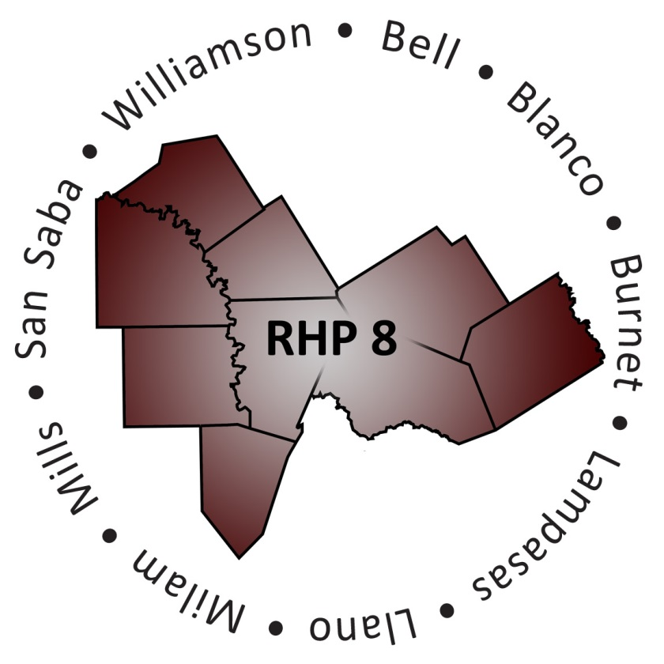
RHP 8 Behavioral Health & Primary Care Cohort

Anchor Team, Co-Facilitators, and Members Roles & Responsibilities

Roles and Responsibilities
A well-managed Cohort is best established when roles and responsibilities are clearly defined. This document is intended to serve as a guide to outline the roles and responsibilities for the Cohort team. It is important to remember that each Cohort member is the expert of his/her own experience, and everyone is on an equal playing field. A well-facilitated Cohort will create a positive flow of ideas and experiences among the members.

Co-Facilitators Overview
The co-facilitators are the guides for the Cohort. The goal of the two co-facilitators is to draw out information and insight from Cohort members. They should use various skills, tools, exercises and natural abilities to efficiently keep the Cohort discussion moving forward.

In general, co-facilitators have three responsibilities:
- Ensure all participants have an an opportunity to address their ideas;
- Guide the discussion in a direction that will help produce a product (e.g., a decision, plan, proposal, or an idea) without rushing; and
- Maintain a safe and respectful environment where Cohort members feel they can share ideas and thoughts without being judged.

Role | Person(s) | Responsibilities
RHP 8 Anchor Team | Jennifer LoGalbo  Gina Lawson | - Offer guidance to Co-Facilitators on topics  - Share information with Co-Facilitators from HHSC that may affect the Cohort  - Draft and disseminate meeting materials before and after meetings  - Attend Cohort meetings
RHP 8 Behavioral Health & Primary Care Cohort Co-Facilitators | Meghan Nadolski  Nicole Williams | - Organize meeting dates and times  - Draft and disseminate meeting materials before and after meetings  - Follow-up and provide meeting minutes to members  - Communicate and share findings of Cohort with RHP 8 stakeholders via a conference call (Cohort members may volunteer to be spokesperson)  - Identify and invite subject matter experts (SMEs) to be a part of Cohort meetings (as needed)
RHP 8 Behavioral Health & Primary Care Cohort Member | Cohort Members | - Share data as developed from group activities and/or general project implementation to help identify and document challenges, lessons learned, successes, etc., for both continuous quality improvement and regional reporting  - Engage in group discussion and be a contributing member of the Cohort  - Collaborate in on-going development of the Cohort  - Provide updates to the Cohort Co-Facilitators as requested  - May volunteer to communicate and share findings of Cohort with RHP 8 stakeholders via a conference call

