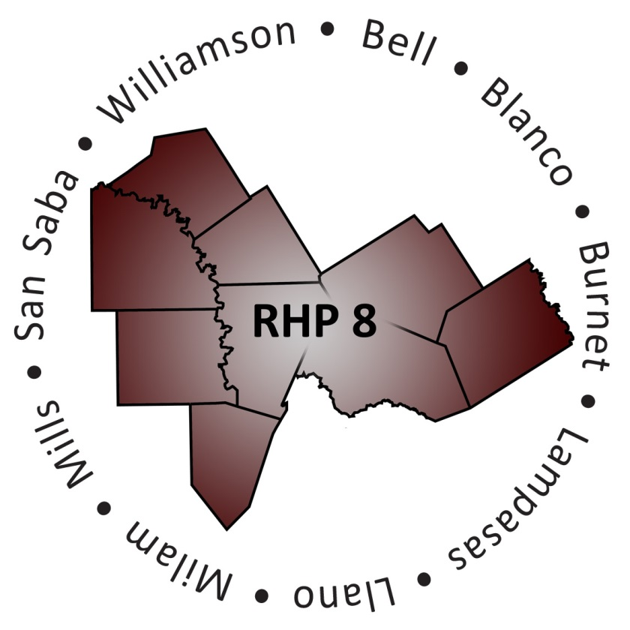
RHP 8 Behavioral Health and Primary Care Cohort
Team Charter

Date: August 17, 2016 |  | Version: 2.1
Cohort Organizations
Baylor Scott & White Medical Center - Llano |  | Lone Star Circle of Care
Bell County Public Health District |  | Seton Highland Lakes
Bluebonnet Trails Community Services |  | Texas A&M Health Science Center
Center for Life Resources |  | Williamson County Emergency Medical Services
Central Counties Services
Purpose Statement
The Cohort will seek opportunities to increase communication and promote shared learning in RHP 8 with an overall focus on project sustainability.
Goals and Aims
Goal 1 | Increase Communication Among Cohort Participants  Completed: September, 2014
Aim 1 | Discuss Access to Care and Finding Resources  Completed: September, 2014
Aim 2 | Develop an RHP 8 County-Based Resource Guide  Completed: September, 2014
Goal 2 | Identify Early Barriers to Care and Develop Plan to Address Obstacles  Completed: March, 2015
Aim 1 | Share Continuing Medical Education (CME) Opportunities for Providers  Removed: December, 2014
Aim 2 | Identify Resources for Payment of Medication for Indigent Patients  Options Explored and Shared: March, 2015
Aim 3 | Identify Resources for Transportation to Care  Options Explored and Shared: March, 2015
Goal 3 | Increase information exchanged related to Waiver renewal in an effort to create a seamless transition into DY6  Completed: August, 2016
Aim 1 | Review HHSC transition proposal plan, and respond to plan by sharing list of questions and/or best practices with others in Cohort  Options Explored and Shared: June, 2016
Aim 2 | Evaluate DSRIP projects using RHP 8 learning collaborative sustainability tool, and take action steps to address areas of improvement  Options Explored and Shared: August, 2016
Goal 4 | Understand potential Regional Performance Bonus Pools (RPBPs) measures and minimize financial risk  Removed: August, 2016
Aim 1 | Understand expectations of HHSC and produce collective response and suggestions to HHSC to positively impact RPBPs in Region  Removed: August, 2016

Outputs
Output 1 | Conduct two PDSAs to (1) identify Cohort Resource List and (2) drive Cohort Development/Planning  Output of Goal 1/Aim 1  Completed: September, 2014
Output 2 | Create and disseminate RHP 8 county-based resource guide used to identify services offered by both RHP 8 Providers and other community organizations  Output of Goal 1/Aim 2  Completed: September, 2014
Output 3 | Create list of CMEs offered in this region; if RHP 8 stakeholders know of opportunities, send information to Anchor to disperse in monthly newsletter  Output of Goal 2/Aim 1  Removed: December, 2014
Output 4 | Create list of resources for payment of medication for indigent patients  Output of Goal 2/Aim 2  Status: Resources and templates shared with members; comprehensive list not created, March 2015
Output 5 | Create list of resources for transportation to care  Output of Goal 2/Aim 3  Status: Resources and templates shared with members; comprehensive list not created, March 2015
Communication Plan
Provide update to stakeholders in region via the RHP 8 newsletter
Share brief recap of Cohort activities on RHP 8 conference calls with regional stakeholders as needed
Meeting Log (Date and Focus of Meeting)
July 31, 2014 |  | Initial Cohort kick-off meeting
August 14, 2014 |  | Cohort development meeting
September 3, 2014 |  | Focus on Goal 1 – discuss aims and outputs related to Goal 1; e.g., draft template for county-based resource list
September 24, 2014 |  | Finish working on county-based resource guide; re-cap activities of HHSC Summit; and discuss next-steps for Cohort
December 3, 2014 |  | DY4 kick-off meeting – identify goals and aims to focus on during DY4
January 21, 2015 |  | Update on research done by Cohort members on medication management resources in the community; review of goals and aims for DY4
March 4, 2015 |  | Presentation provided by Faith Mission on Washington County Medication Assistance Program (MAP); members discussed information Beth McClary found via HOGG Foundation; Anchor team shared insights on how to address transportation gap in region without reinventing the wheel
March 23, 2015 |  | Subgroup met to explore grant funding for access to emergency medication
January 20, 2016 |  | DY5 Initial Cohort kick-off meeting
February 18, 2016 |  | Draft Cohort Charter with goals and aims for DY5
April 7, 2016 |  | Review Cohort member’s experiences with internally reviewing Waiver transitional year materials, and address related questions/concerns/issues.
May 19, 2016 |  | Discuss Waiver renewal concerns/questions, and review project sustainability and evaluation tools.
June 16, 2016 |  | Review benefits of various program sustainability tools; review HHSC transition proposal plan; share concerns/questions with members in Cohort related to sustainability planning and reporting during DY6
August 17, 2016 |  | Discuss Waiver extension activities; providers share what they have learned about DSRIP projects through evaluation process and next steps they plan to take to improve projects

