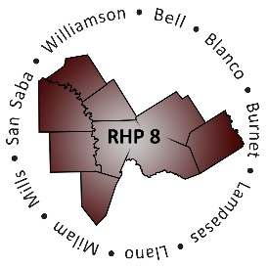
AGENDA

- Welcome/Introductions

- Overview of Texas 1115 Waiver Renewal (DY7-11)

- RHP Plan Update: DY7-8 Plan Submission and Community Needs Assessment
  - RHP Plan Update Requirements
  - Review of Regional Plan Development
  - Review Regional Planning Timeline
  - Updated Community Needs Assessment

- Open Discussion/Questions and Answer

- Wrap-Up/Adjourn

