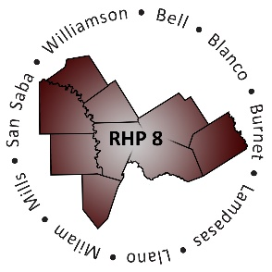
RHP 8 and RHP 17
DY7 Biannual Learning Collaborative Event

Baylor Scott & White Hospital – College Station
Monday, May 7, 2018
Bryan Auditorium
9:00 a.m. – 2:30 p.m.
AGENDA
Time | Item/Speaker | Topics
9:00 am  9:55 am | Registration & Networking | Sign-in, Networking
10:00 am  10:10 am | Jason Jennings, President, College Station Region  Baylor Scott & White Health System | Welcome
10:15 am  11:00 am | Nancy W. Dickey, MD  President Emeritus, Texas A&M Health Science Center  Executive Director, A&M Rural & Community Health Institute | Rural Health Issues, Challenges & Future Direction
11:00 am  11:45 am | Andrew Karrer, Community Paramedicine Coordinator  Montgomery County Hospital District  Montgomery County Public Health District | Paramedicine and Partnering: Collaborating to Better Serve the Rural Community
11:50 am  12:00 pm | Break: Pick up Lunch
12:05 pm  12:50 pm | Lunch with Networking Activity  Susan Seidensticker, Director, Waiver Quality Operations  University of Texas Medical Branch | Raise The Floor: Practical Applications for Cause and Effect
12:50 pm  1:00 pm | Break
1:00 pm  2:15 pm | Tamara Hunter, Senior Manager  Myers and Stauffer, LLC  Alisha Larson Gallmeier, Manager  Myers and Stauffer, LLC | Compliance Monitoring Overview and Considerations in Preparing to Report DY7-8 Outcomes
2:15 pm  2:30 pm | Shayna Spurlin  Associate Director, 1115 Anchor Teams  Texas A&M Health Science Center | Brief Overview of DY7-8 Plan Submission and Closing Remarks

