Agenda
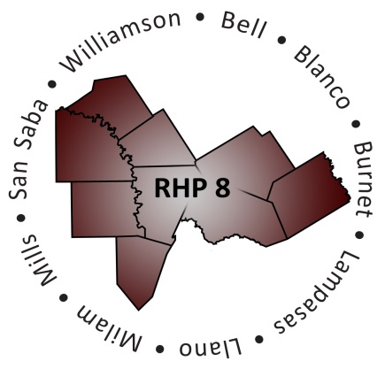

- Welcome/Introductions

- Uncompensated Care (UC) Update
  - DY5 UC Payment Process and Timeline
  - DY6 UC Reporting Process and Timeline
  - Latest CMS Deferral & Statewide Analysis update

- Delivery System Reform Incentive Payment (DSRIP) Update
  - DY5 April Reporting Review Status
  - DY5 April Payment Timeline
  - Compliance Monitoring Process and Timeline

- Texas 1115 Waiver Extension/Renewal Update
  - Brief Overview of Process and Timeline
  - Approved Extension and Transition Period
  - Brief Update on Long-term Waiver Renewal
  - HHSC Proposed Changes to DSRIP program
  - Regional Considerations and Unknowns

- Open Discussion/Questions and Answer

- Upcoming Regional Events

- Wrap-Up/Adjourn

