Regional Healthcare Partnership 8 (RHP 8)
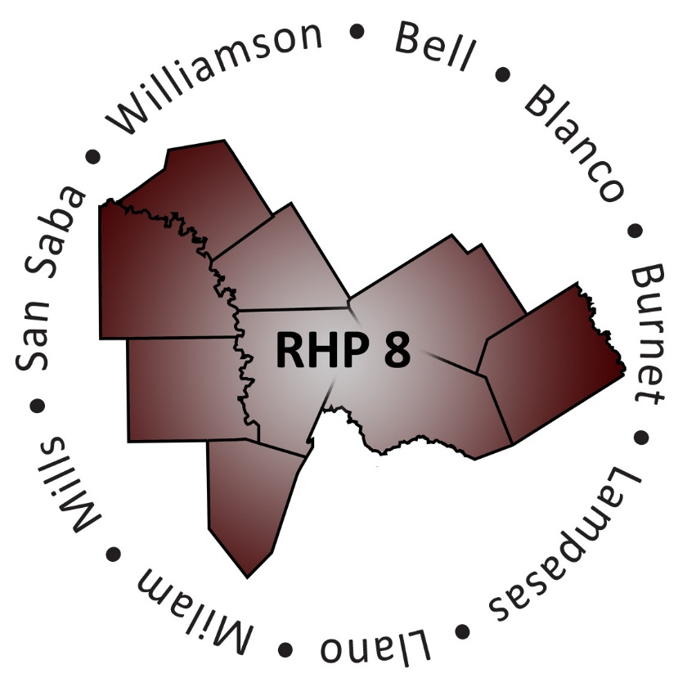
Williamson County DSRIP Summit
Tuesday, May 26, 2015 • 1:00-2:30 p.m.
Cedar Park Recreation Center
1435 Main Street • Cedar Park, Texas • 78613

Agenda

Welcome, Purpose and Goals of the Event
Honorable Cynthia Long, Williamson County Commissioner Precinct Two

Overview of RHP 8
Jennifer LoGalbo, Program Director - RHP 8 Anchor Team

Presentation of Select Williamson County DSRIP Projects
Moderator:
Jennifer LoGalbo, Program Director - RHP 8 Anchor Team
Presenters:
Annie Burwell, Director, Williamson County Mobile Outreach Team
Michelle Hays, Chief Financial Officer, St. David’s Round Rock Medical Center/Georgetown Hospital
Andrea Richardson, Executive Director, Bluebonnet Trails Community Services
Kenny Schnell, Director, Williamson County Emergency Medical Services

Open Forum

Closing Remarks and Adjourn
Honorable Cynthia Long, Williamson County Commissioner Precinct Two

