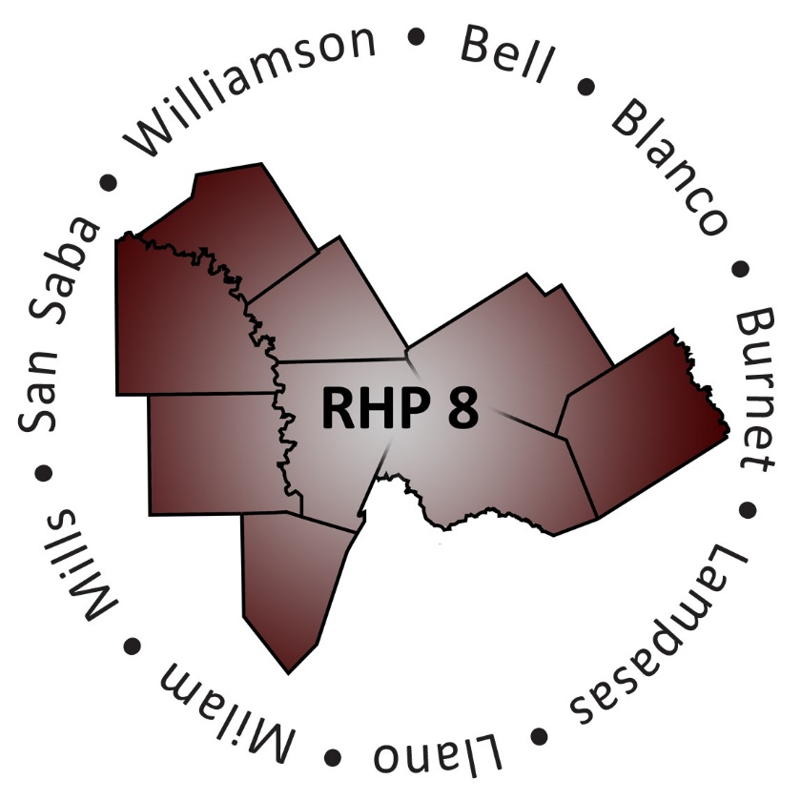
AGENDA

- Welcome/Introductions

- Uncompensated Care (UC) Update
  - DY6 UC Reporting Process and Timeline
  - CMS Deferral Update

- Delivery System Reform Incentive Payment (DSRIP) Update
  - DY6 April Reporting Review Status
  - DY6 April Payment Timeline
  - Compliance Monitoring Update

- Texas 1115 Waiver Extension/Renewal Update
  - Update on Long-Term Waiver Renewal Negotiations
  - Proposed Changes and DSRIP Protocols for DY7-8
  - Provider and Region Requirements for DY7-8
  - Tentative Regional Planning Timeline
  - Regional Considerations and Unknowns

- RHP Plan Update: Community Needs Assessment and New DSRIP Participation

- Open Discussion/Questions and Answer

- Wrap-Up/Adjourn
  - Upcoming Regional Events

