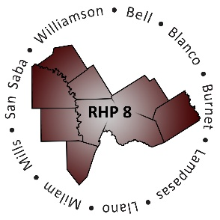
RHP 8 and RHP 17
DY6 Biannual Learning Collaborative Event

Baylor Scott & White Hospital – College Station
Wednesday, July 19, 2017
Bryan Auditorium
9:00 a.m. – 2:30 p.m.
AGENDA
Time | Item/Speaker | Topics
9:00 am  9:55 am | Registration & Networking | Sign-in, Network, View Project Posters
9:55 am  10:05 am | Shayna Spurlin, Associate Director  Texas A&M University Health Science Center | Welcome and Introductions
10:05 am  10:35 am | Jenny Jones, Associate Vice President  Governmental and Public Affairs  Texas A&M University Health Science Center | The Politics of Health Care
10:40 am  11:20 am | Dr. Shao-Chee Sim, Vice President for Applied Research  Jo Carcedo, Vice President for Grants  Episcopal Health Foundation | Health Has a New Voice in Texas: Episcopal Health Foundation’s Research & Grantmaking
11:25 am  11:55 am | Pat Schoenemann, Director  Brazos Health Resource Center | Brazos Health Resource Center: Communication, Coordination and Networking
11:55 am  12:10 pm | Break: Pick up Lunch
12:10 pm  12:50 pm | Lunch with Networking Activity  Jennifer LoGalbo, RHP 8 Program Director  Texas A&M University Health Science Center | Raise The Floor Activity: Strategy Maps
12:50 pm  1:00 pm | Break
1:05 pm  1:35 pm | Cindy Quinn, Program Manager  Center on Population Health & Aging  Texas A&M University Health Science Center | Project Perspective: Market Analysis of DSRIP Services
1:40 pm  2:25 pm | Kimberly Tucker  Senior Policy Analyst  Texas Health & Human Services Commission | Texas 1115 Transformation Waiver and DSRIP DY7-8
2:25 pm  2:30 pm | Shayna Spurlin  Associate Director, 1115 Anchor Teams  Texas A&M Health Science Center | Closing Remarks

