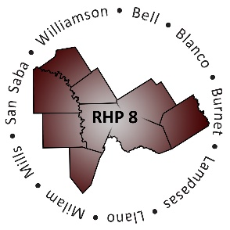
RHP 8 and RHP 17
DY5 Biannual Learning Collaborative Event

Baylor Scott & White Hospital – College Station
Thursday, July 28, 2016
Bryan Auditorium, 5th floor
9:00 a.m. – 2:30 p.m.
AGENDA
Time | Item/Speaker | Topics
9:00 am  10:00 am | Registration & Networking | Sign-in, Network, View Project Posters
10:00 am  10:10 am | Shayna Spurlin  Associate Director, 1115 Anchor Teams  Texas A&M Health Science Center | Welcome & Introductions
10:10 am  10:40 am | Ayanna Clark  Senior Health Policy Analyst  Texas Health & Human Services Commission | Outcome Measures: Population Health & Regional Data Analysis
10:40 am  11:20 am | RHP 17: Debbie Muesse  Program Manager, Brazos Valley Care Coordination Program  Texas A&M Rural & Community Health Institute  RHP 8: Annie Burwell  Director, Mobile Outreach  Williamson County EMS | RHP 8 & 17 Spotlights: Project Outcome Improvement
11:20 am  12:15 pm | Managed Care Organization Panel  Facilitated by Carmela Perez, Program Coordinator  Texas A&M Health Science Center | MCO Representatives Provider Insight on Areas of Interest to Rural DSRIP Providers
12:15 pm  1:00 pm | Break: Lunch & Networking
1:00 pm  1:45 pm | John Cramer  System Director, Organization Effectiveness  Texas 1115 Waiver DSRIP Program  Memorial Hermann Health System | Raise The Floor: Creative Thinking to Address Challenges
1:45 pm  2:25 pm | Ayanna Clark  Senior Health Policy Analyst  Texas Health & Human Services Commission | Waiver Renewal Update
2:25 pm  2:30 pm | Shayna Spurlin  Associate Director, 1115 Anchor Teams  Texas A&M Health Science Center | Closing Remarks

