Regional Healthcare Partnership 8 (RHP 8)
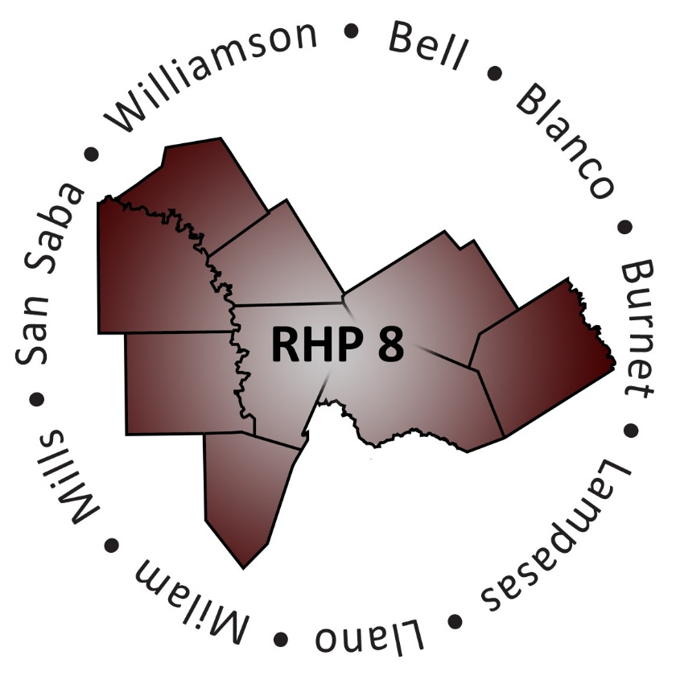
Learning Collaborative
Wednesday, August 5, 2015 • 10:00 a.m.-2:00 p.m.
Georgetown Health Foundation Community Rooms
2425 Williams Drive, Georgetown, Texas 78628

Registration

Purpose and Goals of the Event
RHP 8 Anchor Team

Keynote Presentation: Defining Continuous Quality Improvement (CQI) and
Its Importance to DSRIP Providers
RHP 3 John Cramer, Memorial Hermann

Break

Enhancing the CQI Program In Your Organization
RHP 10 Sascha Chatman, JPS Health Network

A Rural Perspective: Improving Care Transitions in Hamilton
RHP 16 Melissa DeLaGarza and Olinda Harbaugh, Hamilton Healthcare System

A Regional Perspective: Using Cohorts to Improve Behavioral Health/Primary Care Integration
RHP 3 Shannon Evans and Haley Jackson, Harris Health System

Closing Remarks and Adjourn
RHP 8 Anchor Team

