Regional Healthcare Partnership 8
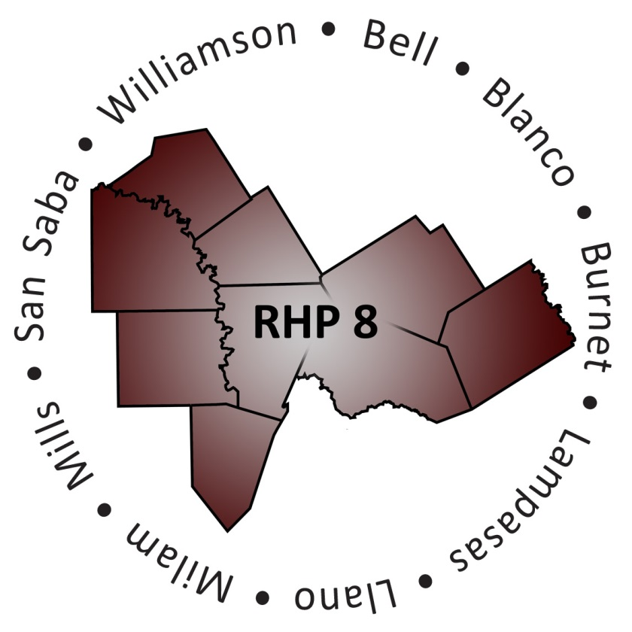
RHP 8 Learning Collaborative
August 20, 2014 • 1:00 – 4:00 p.m.
Georgetown Chamber of Commerce
1 Chamber Way, Georgetown, Texas 78626

Agenda

- Welcome and Introductions
(1:00 – 1:15 p.m.)

- Ramdas Menon, Ph.D.
Deputy Director of Medicaid Health IT, Texas Health & Human Services Commission
Presentation: “Big Data, Big Health: The Link between Data Collection Management and Combating Obesity”
(1:15 – 1:50 p.m.)

Question & Answer
(1:50 – 2:00 p.m.)

- Break
(2:00 – 2:10 p.m.)

- Transforming Healthcare in Central Texas through the 1115 Waiver
Marlene Buchanan, LPC and Mary Kay Schambureck, QMHP
Bluebonnet Trails Community Services
Presentation: “Increasing Physical Activity and Improving Overall Health of Juveniles in Burnet County”
(2:10 – 2:40 p.m.)

Matt Richardson, MPH and Mary Faith Sterk, LCSW
Williamson County & Cities Health District
Presentation: “Collecting, Analyzing, and Leveraging Big Data to Target Disparate Health Populations”
(2:45 – 3:20 p.m.)

Question & Answer
(3:20 – 3:30 p.m.)

- Update from RHP 8 Behavioral Health/Primary Care Cohort Facilitators
Ray Helmcamp, Ph.D. – Facilitator, Central Counties Services
Joey Smith, MBA, LPC – Co-Facilitator, Center for Life
(3:35 – 3:45 p.m.)

- Closing Remarks and Adjourn
(3:50 – 4:00 p.m.)

