Regional Healthcare Partnership 8
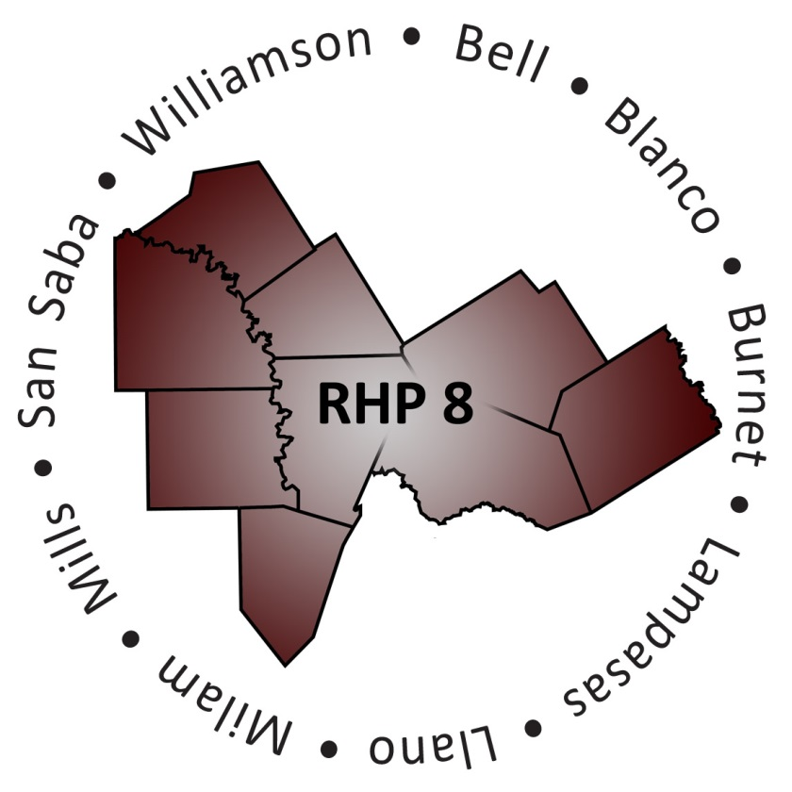
Overview of Projects by Provider

Performing Provider Type: County Health District
Provider Name: Bell County Public Health District; County: Bell; IGT Entity: Bell County Public Health District
- 088334001.2.1 - Increase the availability of sexually transmitted disease (STD) testing at Health District clinics for male clients to ultimately decrease the possible harmful related outcomes associated with untreated infections.
- 088334001.2.2 - Increase the availability of STD testing at Health District clinics for female clients to ultimately decrease the possible harmful related outcomes associated with untreated infections.

Provider Name: Williamson County and Cities Health District; County: Williamson; IGT Entity: Williamson County and Cities Health District
- 126936702.1.1 - Expand capacity of access to preventive clinical care through availability of same day or next day appointments by increasing the level of healthcare professionals and extended hours at four local health clinics located in Cedar Park, Round Rock, Taylor, and Georgetown. This differs from the St. David’s Access2Care program which focuses on acute care for individuals under the 200% federal poverty line.
- 126936702.1.2 - Implement Community Paramedicine in rural communities which will increase access to proactive healthcare and decrease the overuse of emergency medical systems (EMS) for non-emergent events, leaving EMS to handle emergent needs.
- 126936702.1.3 – Enhance and improve the quality and consistency of public health client demographic (race, ethnicity, gender, and language) data collection and interpretation to ensure health disparities are addressed appropriately.
- 126936702.2.1 - Provide navigation services to persons with targeted chronic conditions or pregnancy that are at high risk of disconnect from institutionalized health care to prevent hospital admissions and readmissions.
- 126936702.2.2 - Use an interdisciplinary team to promote preventive health awareness by offering health education classes, eligibility assistance, case management and health literacy education in the community, specifically for women of child bearing age, with a high incidence rate of frequent hospitalizations for chronic conditions, and/or in need of prenatal care.
- 126936702.2.100 - Implement innovative evidence-based strategies to reduce and prevent obesity in children and adolescents.

Performing Provider Type: Local Mental Health Authority
Provider Name: Bluebonnet Trails Community Center; County: Burnet and Williamson; IGT Entity: Bluebonnet Trails Community Center
- 126844305.1.1 - Provide outpatient behavioral health (BH) services to a low income and rural area in Taylor that are currently ineligible for services.
- 126844305.1.2 - Create, certify, and provide for an involuntary 48-Hour Observation Emergency Detention Unit for the purpose of providing crisis stabilization in Georgetown to provide for emergency and crisis stabilization services in a secure and protected, clinically staffed, psychiatrically supervised treatment environment.
- 126844305.1.3 - Develop specialized Therapeutic Foster Care (TFC) to intervene with youth in crisis, diverting them from admission to hospitals or juvenile justice facilities.
- 126844305.1.4 - Collaborate with Burnet County Sheriff's Department and Seton Highland Lakes Medical Center to provide crisis assessment, referral, and short-term stabilization in Burnet County.
- 126844305.1.5 - Establish outpatient substance abuse treatment sites in Georgetown and Marble Falls to meet the needs of a growing population, especially the poor, under or uninsured.
- 126844305.2.1 - Secure, renovate, open and staff transitional housing facilities in Williamson County for individuals who will be provided BH services in this transitional housing setting to improve community living skills and transition into independent living.
- 126844305.2.2 - Use healthcare teams to reduce utilization of emergency services by individuals identified as high utilizers; those identified will be offered proactive care in settings other than emergency departments (EDs) including their homes.
- 126844305.2.3 - Provide intensive wrap around services called Assertive Community Treatment (ACT) for individuals with intellectual and developmental disabilities (IDD) at the point of crisis and during life transitions to prevent them from being placed in institutions or inappropriately using EDs and crisis services.
- 126844305.2.4 - Expand the clinical capacity and eligibility criteria for youth and adults arrested or incarcerated in Burnet and Williamson counties. Provide screening, assessment, and diversion recommendations prior to long-term incarceration; this includes linkage to community BH care.

Provider Name: Center for Life Resources; County: San Saba and Mills; IGT Entity: Center for Life Resources
- 133339505.1.1 - Implementation of a telemedicine model to provide clinically appropriate treatment as indicated by a psychiatrist or other qualified provider throughout Mills and San Saba counties. Thus, reducing unnecessary ED and service use, and improve consumer satisfaction/access were previously limited or unavailable.

Provider Name: Central Counties Services; County: Bell, Lampasas, and Milam; IGT Entity: Central Counties Services
- 081771001.1.1 - Provide school-based mental health (MH) services for children, K-5th grade, who have difficulty adjusting to the classroom environment due to emotional/behavioral problems. Counseling services may include the child’s family.
- 081771001.1.2 - Double telepsychiatry use from 1 full time employee (FTE) to 2 FTEs by enabling up to 4 simultaneous telepsychiatry/ telehealth users on a high quality telemedicine system. This project also funds a second FTE psychiatric provider to improve both timely patient access to psychiatry services and medication compliance.
- 081771001.1.3 - Implement group social skills training for persons diagnosed with high-functioning Autism or Asperger's disorder in the Bell County area.
- 081771001.1.4 - Provides 24/7 residential-based crisis respite (15 beds), transitional living (15 beds), and supportive day services at a properly equipped facility within service area to persons with severe and persistent mental illness (SPMI) who have experienced a recent MH crisis, in lieu of these persons being sent to the state psychiatric hospital system or incarcerated in local jails.
- 081771001.1.5 - Provides improved data management and organizational process improvement capacity which will allow Provider to focus on reducing readmissions to state psychiatric hospital and local jails by improving post discharge follow-up services. This project seeks to improve the efficiency of clinical service operations through improved technology and thus increase the Provider’s capacity.
- 081771001.2.1 - Provide education, training, and support by a registered nurse for persons with SPMI having chronic health conditions due to prolonged psychiatric medicine use. The project builds the patient’s ability/desire to improve their self-managing of chronic health condition(s), instead of stopping psychotropic medicine that helps their psychiatric symptoms.
- 081771001.2.2 - Provides persons (both adults and adolescents) with SPMI easy access to STD education, testing, and treatment by a registered nurse (RN) within the Provider’s mental health clinics in Temple and Killeen, where the patients are already accustomed to attending.
- 081771001.2.3 - Provide supportive day services for adults with SPMI who were recently discharged from a psychiatric hospital or jail, or have recently experienced a crisis that put them at risk for hospitalization/incarceration.
- 081771001.1.100 - A natural extension of project number 081771001.1.3. Project will bridge the gap between social skills training in the current project and work adjustment training in the new project for persons diagnosed with high-functioning Autism or Asperger's disorder in the Bell County area.
- 081771001.2.100 - Provides trained law enforcement officers opportunity to assess the BH acuity of someone involved in a minor criminal event, and to direct that person into the BH service system instead of the criminal justice system.

Provider Name: Hill Country MHDD Centers; County: Blanco and Llano; IGT Entity: Hill Country MHDD Centers
- 133340307.2.1 - Implement co-occurring psychiatric and substance use disorder services (COPSD) in Blanco and Llano counties in order to meet the needs of individuals with psychiatric and substance use issues within the community setting; thus, reducing ED utilization, impatient utilization, and incarceration.
- 133340307.2.2 - Implement trauma informed care services in Blanco and Llano counties to meet the need of individuals who experienced trauma that is impacting their BH.
- 133340307.2.3 - Implement psychiatric and clinical guidance 24/7 for primary care physicians and hospitals within Blanco and Llano counties to help physicians identify and treat BH symptoms earlier to avoid exacerbation of symptoms into a BH crisis.
- 133340307.2.4 – Implement Whole Health Peer Support services within Blanco and Llano counties to meet the overall health needs of individuals who have BH issues.
- 133340307.2.5 - Implement Veteran Mental Health Services within the Blanco and Llano counties to meet the overall health needs of veterans dealing with BH issues. Project will expand peer support services in an effort to identify veterans and their family members who need comprehensive community based wrap around BH services.

Performing Provider Type: Hospital
Provider Name: Scott & White – Llano; County: Llano; IGT Entity: Llano County
- 020840701.2.1 - Apply continuous process improvement (CQI) strategies guided by the Institute for Healthcare Improvement (IHI) Model to identify causes of avoidable EMS and ED utilization; prioritize potential solutions; and launch Plan, Do, Study, Act (PDSA) cycles on chosen improvements.
- 020840701.2.2 - Apply CQI guided by the IHI Model for Improvement to identify causes of avoidable Sheriff Department Transport of BH patients in crisis; prioritize potential solutions; and launch PDSA cycles on chosen improvements.

Provider Name: Scott & White – Memorial; County: Bell; IGT Entity: Bell County
- 137249208.2.1 - Provide patient navigation and selected chronic illness supports for a target group of people who are members/beneficiaries of the Bell County Indigent Care Program, Medicaid, and/or participating hospitals' charity care programs.

Provider Name: Seton Highland Lakes; County: Burnet; IGT Entity: Burnet County
- 094151004.2.1 - Implement a patient navigation system to connect indigent and uninsured patients with primary care or medical homes in order to reduce ED utilization and provide cost effective, timely, and site appropriate health care services. Patients will be routed to a medical home by care navigators responsible for managing long-term relationships with the patients to reduce the patient’s need for advanced medical care, including the ED.

Provider Name: Little River Healthcare; County: Milam; IGT Entity: Rockdale Hospital District
- 183086102.1.1 - Increase the number of Primary Care Physicians (PCPs) which will allow the hospital to increase clinic hours and provide earlier diagnosis of chronic and life-threatening disease states prior to the disease requiring an ED visit and urgent care; thus, enabling the ED for true emergencies.
- 183086102.1.2 - Increase the access to Specialty Care Physicians (SCPs) by expanding the number of specialty providers and/or increasing clinic hours for the specialists most in demand. This will promote early diagnostic and screening services for at-risk patients including low income and uninsured individuals.
Provider Name: St. David’s Round Rock Medical Center; County: Williamson; IGT Entity: Williamson County
- 020957901.1.1 - Expand availability of primary care services to target low income population in Williamson County that do not have existing health coverage by working with existing local clinics and an FQHC to provide services to the population.

Provider Name: Seton Harker Heights; County: Bell; IGT Entity: Bell County
- 013122392.1.100 - Expand existing primary care capacity to provide patients with increased access to primary care services (preventive, primary, and chronic care) in Bell County by supporting the Greater Killeen Free Clinic.

UC-Only Hospitals:
Bell County:
- Cedar Crest Hospital
- Metroplex Health System
- Scott & White Clinic
Lampasas County:
- Rollins Brook Community Hospital
Williamson County:
- Cedar Park Regional
- Scott & White – Round Rock

