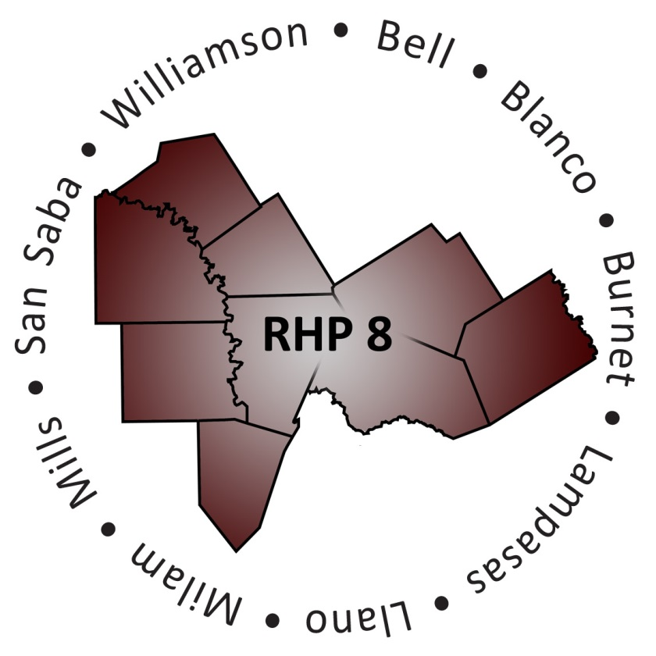
Regional Healthcare Partnership 8
Overview of the 1115 Medicaid Waiver
August 20, 2014 • 1:00-4:00 p.m.

What is the Texas Medicaid 1115 Waiver?
A five-year program, spanning 2011 through 2016, that expands Medicaid managed care statewide and creates an Uncompensated Care (UC) Pool and a Delivery System Reform Incentive Payment (DSRIP) Pool. Through the DSRIP program, hospitals and other Providers earn incentive payments for investments in delivery system reforms that increase access to healthcare, improve the quality of care, and enhance the health of patients and families.

What is Regional Healthcare Partnership (RHP) 8?
One of twenty regions in Texas, RHP 8 includes 9 counties, with 12 DSRIP Providers implementing more than 90 projects valued at over 100 million dollars. Projects are designed to address community needs and achieve the Triple Aim goals of improving the patient experience of care (including quality and satisfaction) and the health of populations, and reducing the per capita cost of healthcare. DSRIP Providers include: public and private hospitals, community mental health centers, public health departments, and physician practices affiliated with academic medical schools.

Texas A&M Health Science Center is the designated “Anchor” for RHP 8 and serves as liaison between the Texas Health and Human Services Commission (HHSC) and the DSRIP providers.

Which Counties are Included in RHP 8?
RHP 8 includes 9 counties in the central Texas region, these include: Bell, Blanco, Burnet, Lampasas, Llano, Milam, Mills, San Saba, and Williamson.

Who are the Eligible and Participating “Providers” in RHP8?
Hospitals |  | Local Health Departments | Community Mental Health Centers
Cedar Park* | Scott & White - Memorial | Bell County Public Health District | Bluebonnet Trails Community Services
Cedar Crest* | Scott & White – Round Rock | Williamson County & Cities Health District | Center for Life
Metroplex Health System* | Seton Harker Heights |  | Central Counties Services
Rollins Brook Community Hospital* | Seton Healthcare Williamson* |  | Hill Country Mental Health& Developmental Disabilities Centers
Scott & White Clinic* | Seton Highland Lakes
Scott & White – Llano | St. David’s Round Rock Medical Center
*Participating in the UC-Only Pool

How were DSRIP Projects Selected?
Each Provider selected projects from a menu called the RHP Planning Protocol. The menu was developed and approved by HHSC and the Centers for Medicare and Medicaid Services (CMS). Each project option included a list of core components and a series of milestones and metrics from which the Providers could choose. Providers selected projects that met the greatest needs of their patients, service areas, and/or communities.

When were Projects Submitted and Approved?
Date | Activity
December 2012 | RHP Plan submitted to HHSC
February 2013 | Revised RHP Plan submitted to HHSC in response to HHSC feedback
April 2013 | RHP 8 received initial findings from CMS
July 2013 | Providers corrected/confirmed DY2 milestones for October (“Phase 3A”)
July 2013 | Providers confirmed/corrected Quantifiable Patient Impact milestones (“Phase 2”)
August 2013 | “Phase 1” project revisions initially approved by CMS (these included projects that had adjustments to value and projects with overlapping milestones)
September 2013 | Providers corrected/confirmed DY2 milestones for October (“Phase 3B”)
December 2013 | Providers submitted technical corrections (“Phase 4”) and DY3-5 plan modifications
December 2013 | RHP Plan amendment submitted with newly proposed three-year projects
March 2014 | Providers submitted new/revised Category 3 milestones
August 2014 | Providers submitted DY4/DY5 change requests (plan modifications and/or technical corrections)
August 2014 | Providers submitted Category 3 feedback as requested to HHSC

How was the Community Engaged in the Development of the RHP 8 Plan?
RHP 8 has stimulated broad stakeholder engagement from the beginning of the process through the rapid dissemination of information, use of a variety of media for communication, and through public meetings. As new information became available from HHSC, the RHP 8 Anchor team focused on interpreting those materials and putting accessible, meaningful information in the hands of stakeholders in the region as quickly as possible. To reach as many people as possible, RHP 8 established the RHP 8 Website in May 2012. It is updated frequently with information. Additionally, throughout both the initial four-year and later three-year project planning processes, RHP 8 has met in public meetings (face-to-face and via conference call).

When were Milestones Reported and Funds Received?
Date | Activity
August 31, 2013 | First reporting opportunity for DY2 milestones
October 28, 2013 | DSRIP payments for approved August-reported milestones
October 31, 2013 | Second reporting opportunity for DY2 milestones  Submission of additional documentation for August-reported milestones designated by HHSC as “needing more information” (NMI)
January 17, 2014 | Submission due date for additional documentation for October NMI milestones
January 7, 2013 | DSRIP payments for approved October-reported milestones and approved August NMI milestones
April 30, 2014 | First reporting opportunity for DY3 milestones and any DY2 milestones that were “carried forward”
July 10, 2014 | DSRIP payments for approved April-reported milestones
July 14, 2014 | Submission of additional documentation for April-reported milestones designated by HHSC as NMI

What are Learning Collaboratives?
All RHP 8 DSRIP Providers and other community stakeholders are encouraged to participate in Learning Collaborative (LC) activities. LCs are designed to facilitate sharing best practices, lessons learned, challenges, solutions, and results. During DY3, the RHP 8 Anchor team has opened many doors for stakeholders in the region to promote collaboration: hosts bi-weekly conference calls in which community participants have the opportunity to share best practices, lessons learned, and success stories with one another; publishes a monthly newsletter which highlights meaningful webinars, and other learning sources to assist Providers in the region to succeed in the implementation of DSRIP projects; supports the on-going development of the Behavioral Health/Primary Care cohort workgroup that brings together like-project leads and allows them to learn from one another; and hosts 2, face-to-face annual events each DY to allow for collaboration in the region.
What do all these Terms and Acronyms Mean?
Common Terms
- Anchoring Entity (Anchor)
The single IGT entity in an RHP serving as the primary contact to HHSC responsible for providing opportunities for public input to the development of RHP plans and coordinating discussion and review of proposed RHP plans prior to plan submission to the State.
- Category (Cat)
Categories 1 and 2 represent the core DSRIP projects related to infrastructure development and program innovation and redesign. Category 3 includes the outcome measures associated with each project. Category 4 is a set of measures reported by participating hospitals.
- Centers for Medicare and Medicaid Services (CMS)
The U.S. federal agency that administers Medicare, Medicaid, and the State Children's Health Insurance Program. CMS granted the Waiver to Texas, approves protocols and RHP Plans, and holds Texas accountable to the Waiver Standard Terms and Conditions.
- Continuous Quality Improvement (CQI)
All projects are required to conduct and report on continuous quality improvement activities.
- Delivery System Reform Incentive Payment (DSRIP – pronounced “dis-rip”)
Incentive payments available for projects under the Transformation waiver to enhance access to health care, increase the quality of care, the cost-effectiveness of care provided and the health of the patients and families served. Projects eligible for incentive payments must come from the DSRIP menu, be included in an HHSC and CMS-approved RHP plan and have corresponding metrics and milestones.
- Demonstration Year (DY)
A 12-month period beginning October 1 and ending September 30. The 1115 Transformation waiver currently consists of five demonstration years from 2011 to 2016. The waiver demonstration years are consistent with Federal Fiscal Years. The first DY involved submission of the RHP Plan. Projects are implemented and outcomes reported during the remaining four DYs.
DY | Federal Fiscal Year (FFY) Calendar Date
DY 1 | October 1, 2011 – September 30, 2012
DY 2 | October 1, 2012 – September 30, 2013
DY 3 | October 1, 2013 – September 30, 2014
DY 4 | October 1, 2014 – September 30, 2015
DY 5 | October 1, 2015 – September 30, 2016
- Disproportionate Share Hospital (DSH – pronounced “dishes”)
Serve a significantly disproportionate number of low-income patients and receive payments from the Centers for Medicaid and Medicare Services to cover the costs of providing care to uninsured patients.
- DSRIP Menu (RHP Planning Protocol)
A menu of HHSC- and CMS-approved projects that contribute to delivery transformation and quality improvement. Only projects from this menu performed as outlined in an HHSC and CMS-approved RHP plan with corresponding metrics and milestones are eligible for payments from the DSRIP pool.
- Federal Financial Participation (FFP)
That portion paid by the Federal government to states for their share of expenditures for providing Medicaid services, administering the Medicaid program, and certain other human service programs.
- Federal Medical Assistance Percentage (FMAP – pronounced “f-map”)
Annual change in the federal/state funding ratio; published each November by the federal government.
- Federal Poverty Level (FPL)
The set minimum amount of gross income that a family needs for food, clothing, transportation, shelter and other necessities. In the United States, this level is determined by the Department of Health and Human Services.
- Health and Human Services Commission (HHSC)
Texas HHSC is responsible for working with CMS to design and implement the 1115 Waiver.

- Health Professional Shortage Area (HPSA)
Designated by U.S. Department of Health and Human Services Health Resources and Services Administration (HRSA) as having shortages of primary medical care, dental or mental health providers and may be geographic (a county or service area), demographic (low income population) or institutional (comprehensive health center, federally qualified health center or other public facility). Medically Underserved Areas/Populations are areas or populations designated by HRSA as having: too few primary care providers, high infant mortality, high poverty and/or high elderly population.
- Intergovernmental Transfer (IGT)
State and local funds derived from taxes, assessments, levies, investments, and other public revenues within the sole and unrestricted control of a governmental entity and eligible for federal match under the 1115 Transformation Waiver. This does not include gifts, grants, trusts, or donations, the use of which is conditioned on supplying a benefit solely to the donor or grantor of the funds.
- Intergovernmental Transfer (IGT) Entity
A governmental entity that provides an IGT to fund the Waiver. A state agency or a political subdivision of the state—such as a city, county, hospital district, hospital authority, or state entity—with IGT eligible for federal match to fund an RHP’s UC or DSRIP.
- Medicaid Managed Care
A system under which the state pays a set fee each month to a health plan to provide care for a Medicaid client, who selects a primary doctor from the plan’s network to coordinate care. This differs from a traditional fee-for-service system that bases provider payment on quantity of service rather than quality. In 2011, the Texas Legislature directed HHSC to expand managed care within the state Medicaid program with the goal of achieving high-quality, cost-effective health care.
- Metric
Quantitative or qualitative indicator of progress toward achieving a milestone from a baseline.
- Milestone
An objective for DSRIP performance comprised of one or more metrics.
- Needs more information (NMI)
The designation given to milestones submitted to HHSC that are not initially approved. Providers have one chance to submit additional supporting documentation for milestone approval. If HHSC does not approve the milestone following this submission, the incentive dollars associated with that milestone are lost.
- Performing Provider (Provider)
A participating Medicaid provider that implements DSRIP projects. Eligible providers include hospitals, community mental health centers, physician providers affiliated with a medical school, and local health departments.
- Primary Care Case Management (PCCM)
A system of managed care used by state Medicaid agencies in which a primary care provider is responsible for approving and monitoring the care of enrolled Medicaid beneficiaries, typically for a small monthly case management fee in addition to fee-for-service reimbursement for treatment.
- Program Funding and Mechanics Protocol (PFM)
A document, drafted by HHSC and pending CMS approval, outlining DSRIP requirements for RHPs including the minimum number of projects, organization of the RHP Plan, plan review process, required reporting, allocation of available pool funds, valuation of projects, disbursement of funds, and plan modifications. The primary policy that defines content of the RHP Plan and how funds are allocated, milestones approved, and payments made.
- Protected Health Information (PHI)
Patient-level data that is to be safeguarded.
- Quantifiable Patient Impact (QPI)
A special designation for one milestone within each project that describes its scope, such as number of unique patients or visits. This milestone is used by CMS to assess the project’s total value.
- Regional Healthcare Partnership (RHP)
A DSRIP feature unique to Texas which allows interested participants working collectively to develop and implement a regional plan for health care delivery system reform.

- RHP Participant
An entity participating in an RHP as outlined in an RHP plan. A participant may be an IGT entity, a performer, an anchor, or another stakeholder.
- RHP Plans
A plan to identify the community needs, the projects, and investments under the DSRIP to address those needs, community healthcare partners, the healthcare challenges, and quality objectives of an RHP. These plans must be submitted to the State and CMS for approval and shall include estimated funding available by year to support UC and DSRIP payments. RHP anchoring entities shall provide opportunities for public input to the development of RHP plans, and shall provide opportunities for discussion and review of proposed RHP plans prior to plan submission to the State.
- Texas Healthcare Transformation and Quality Improvement Program 1115 Waiver (Waiver)
A Waiver under section 1115 of Social Security Act that allows CMS and states more flexibility in designing programs to ensure delivery of Medicaid services. The vehicle approved by HHSC and CMS for expansion of managed care within the State Medicaid program while preserving federal supplemental hospital funding historically provided under the upper payment limit (UPL) program.
- Texas Provider ID (TPI)
Providers must have a Medicaid TPI. The provider’s TPI is part of each project ID.
- Triple Aim
Originally developed by the Institute for Healthcare Improvement (IHI), the Triple Aim is a framework that describes an approach to optimizing health system performance. Adopted by CMS, the goals of the Triple Aim are defined as:
- Improving the patient experience of care (including quality and satisfaction),
- Improving the health of populations, and
- Reducing the per capita cost of healthcare.
- Uncompensated Care (UC)
The funding pool available to RHP participants under the Waiver to defray uncompensated care costs (no funds or third party coverage for services provided by the hospital or other providers).
- Uncompensated Care Application (UC Protocol)
The documentation needed for hospitals and other providers to report their uncompensated costs to receive reimbursement under the Transformation waiver.
- Upper Payment Limit (UPL)
Historic supplemental payments made to certain hospitals and providers to make up the difference between what Medicaid actually paid for Medicaid clients and what Medicare would have paid for the same services. UC and DSRIP funds available under the 1115 Transformation waiver replaced funding available under the former UPL program.

Who Should I Contact for Additional Information?
Angie Alaniz
Director, 1115 Waiver Teams (RHP 8 & RHP 17)
979-458-1594
alalaniz@sph.tamhsc.edu

Jennifer LoGalbo
Program Director, Regional Healthcare Partnership 8
512-341-4962
logalbo@tamhsc.edu

Gina Lawson
Program Assistant, Regional Healthcare Partnership 8
512-341-4975
glawson@tamhsc.edu

