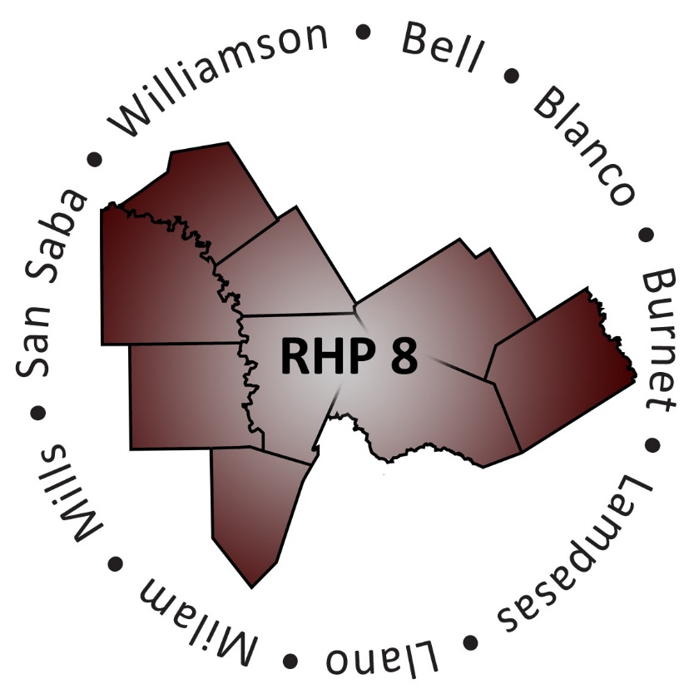
AGENDA

- Welcome/Introductions

- Uncompensated Care (UC) Update
  - DY7 Final Payments and Timeline
  - DY8 Payments
  - DY9-11 UC Protocols

- Delivery System Reform Incentive Payment (DSRIP) Update
  - DY7-8 Plan Update Submission
  - DY7-8 Plan Update Feedback and Plan Access
  - DY7 Reporting (August and October)
  - Compliance Monitoring Update
  - DY9-10 DSRIP Protocols

- Regional Updates and Activities
  - Regional Overview (Quick Facts)
  - Learning Collaborative Activities
  - Updated Regional Timeline
  - Updated Draft Payment Schedule
  - Anchor Team Update

- Open Discussion/Questions and Answer

- Wrap-Up/Adjourn

