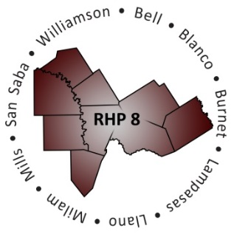
Regional Healthcare Partnership 8
Wednesday, September 4, 2013 • 1:30 p.m. – 3:30 p.m.
3950 North A.W. Grimes Blvd., Room S307 • Round Rock, Texas 78664

AGENDA

- Welcome and Introductions

- DY2 Project Activities: Payments and Reporting
- Payments
  - UC
    - UC Tool Expected to be Released by HHSC in Late-September
  - Updates/Revised Timelines
- Reporting
  - DSRIP
    - August Re-cap
    - October Due Dates/Reminders
    - Phase 3B – October Milestones and Metrics

- DY3 Planning
- Anticipated Planning Process and Timeline
  - Project Proposal Form – Sent to RHP 8 Tuesday, Sept. 3; Due Back to Anchor Tuesday, Sept. 17
  - Prioritized Regional List
  - Overview of ‘Scoring Process’ for New, DY3 Projects
- Plan Modifications and Upcoming Work Sessions for Existing Projects

- Learning Collaboratives
- Overview of LC Process
  - Brainstorming/Input from RHP 8 Stakeholders
- Upcoming Learning Collaborative: Thursday, Sept. 19

- Upcoming Meetings/Communications
- Frequency/Location/Style
- Updating Website

- Next Steps/Q&A

- Adjourn

