Regional Healthcare Partnerships 8 and 17
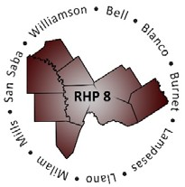
Joint Regional Update Meeting
Thursday, September 15, 2016
9:30 a.m. – 11:30 a.m. (via WebEx)
Texas A&M Health Science Center

WebEx Link: Join WebEx Meeting
Meeting Number: 921 021 998

Audio/Conference Line: 877-931-8150
Participant Code: 3621413 (please note access code changed)

AGENDA

- Welcome/Introductions

- Uncompensated Care (UC) Update
  - Payments & Schedules
  - Reminders
  - Brief Overview of Statewide UC Analysis Report

- Delivery System Reform Incentive Payment (DSRIP) Update
  - DY5 October Reporting Review
  - Compliance Monitoring Update
  - Brief Overview of DY6 Project Requirements

- Texas 1115 Waiver Extension/Renewal Update
  - Brief Overview of Anticipated Process/Timeline
  - Approved Extension
  - Update on Current Activities/Issues
  - Regional Considerations and Unknowns

- Open Discussion/Q&A

- Upcoming Regional Events

- Wrap-Up/Adjourn

