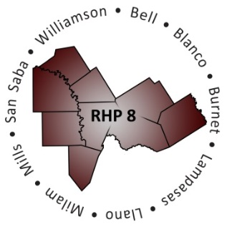
Regional Healthcare Partnership 8
Review and Prioritization of DY3 Proposed Projects
Tuesday, October 15, 2013 • 10:00 a.m. – 10:30 a.m.
3950 North A.W. Grimes Blvd., Room S307 • Round Rock, Texas 78664

AGENDA

- Welcome and Introductions

- Review New, DY3 Proposed Projects
  - Alignment with Community Needs
  - Transformational Impact
  - Integration with Other Projects or Partners
  - Likelihood of Success
  - Sustainability

- Prioritize New, DY3 Proposed Projects
  - Review Total Weighted Score
  - Ensure Projects Alternate between IGT Entities

- Question & Answer

- Adjourn

