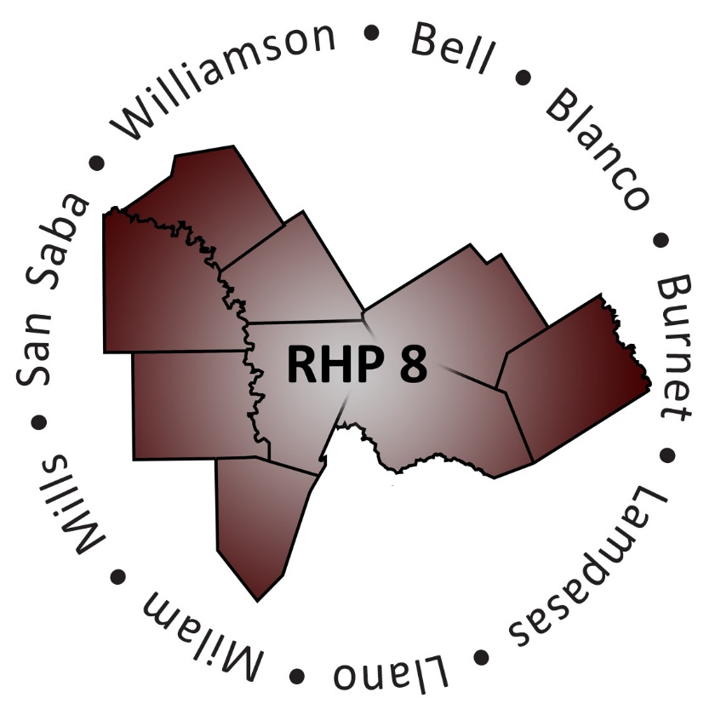
AGENDA

- Welcome/Introductions

- Uncompensated Care (UC) Update
  - DY6 UC Reporting Process and Timeline
  - Latest CMS Deferral & Statewide Analysis update

- Delivery System Reform Incentive Payment (DSRIP) Update
  - DY5 October Reporting Review Status
  - DY5 October Payment Timeline
  - Latest Compliance Monitoring Process & Timeline

- Texas 1115 Waiver Extension/Renewal Update
  - Recap of Approved Extension/Transition Period (DY6)
  - Latest Update on Long-term Waiver Renewal
  - Regional Considerations and Unknowns

- Open Discussion/Questions and Answer

- Upcoming Regional Events

- Wrap-Up/Adjourn

