Regional Healthcare Partnerships 8 and 17
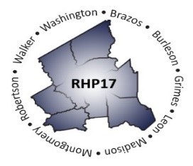
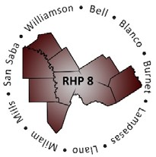
Joint Quarterly Regional Update
Wednesday, March 30, 2022
10:00 – 11:30 AM (via Zoom Webinar)
Texas A&M University Health Science Center

Webinar Link: Join Zoom Meeting
Meeting Number: 977 5049 8017
Meeting Passcode: 628619

AGENDA

- Welcome/Introductions

- Brief Uncompensated Care (UC) Update

- Delivery System Reform Incentive Payment (DSRIP) Update
  - October DY10 Reporting and Payment Summary
  - April DY11 Reporting Prep and Reminders
  - DSRIP Transition/Considerations

- Texas 1115 Waiver Update
  - Brief 1115 Waiver Extension Update
    - Rescission, Appeal, and Injunction
    - Post-DSRIP Programs

- Open Q&A/Wrap-Up

