Regional Healthcare Partnerships 8 and 17
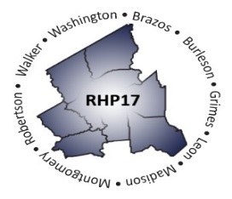
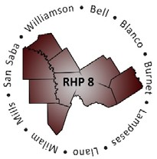
Joint Quarterly Regional Update
Thursday, December 12, 2019
9:30 a.m. – 11:00 AM (via Zoom Webinar)
Texas A&M Health Science Center

Webinar Link: Join Zoom Meeting
Meeting Number: 184 849 733

Audio/Conference Line: Dial in: 877-931-8150; Code: 3621413

AGENDA

- Welcome/Introductions

- Uncompensated Care (UC) Update
  - Brief Recap DY9-11 UC changes
  - DY9 UC Reporting Process and Timelines
  - Update on CMS Deferral and HHSC Appeal

- Delivery System Reform Incentive Payment (DSRIP) Update
  - October DY8 Reporting & Payment Reminders
  - DY8 RHP Annual Reports
  - Brief Compliance Monitoring Update
  - DY9 Learning Collaborative Activities

- Texas 1115 Waiver Update (DY9-10)
  - RHP 8 and 17 Plan Updates for DY9-10
  - Texas DSRIP Transition Plan Update

- Other Waiver-Related Updates
  - Local Provider Participation Fund (LPPF) Updates
    - Affiliation and TIN changes
    - Required LPPF Quarterly Reporting
  - UHRIP Program: HHSC requested Feedback and Public Meeting
  - Proposed CMS Finance Rule Changes

- Open Q&A/Wrap-Up

