AGENDA
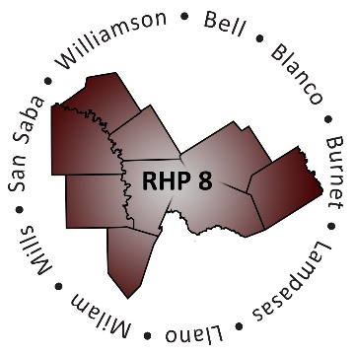

- Welcome/Introductions

- Uncompensated Care (UC) Update
  - DY7 UC Recap
  - DY8 UC Reporting Process and Timeline

- Delivery System Reform Incentive Payment (DSRIP) Update
  - DY7 October Reporting Review
  - DY7 October Payment Timeline & Reminders
  - April DY8 Reporting/Plan Modification Request Deadlines
  - Brief Compliance Monitoring Update

- Texas 1115 Waiver Update (DY9-10)
  - Update on drafts of DY9-10 Protocols
  - Regional Considerations and Unknowns
  - Timeline of Texas Due Dates

- Open Discussion/Questions and Answer

- Wrap-Up/Adjourn
  - Accessing the RHP Plans
  - Upcoming Regional Events

