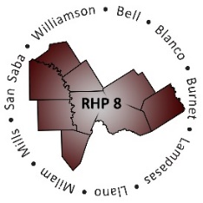

AGENDA
- Welcome/Introductions

- Review HHSC DY9-10 RHP Plan Update Templates and Guidance Documents
  - Documents Available on the HHSC Waiver Website
    - Program and Funding Mechanics (PFM) Protocol
    - Measure Bundle Protocol (MBP)
  - Documents Available on the HHSC Online DSRIP Reporting System Bulletin Board
    - Functional RHP Plan Update Template (posted 10/01/2019)
    - RHP Plan Update Companion Document (posted 10/01/2019)
    - Category C Summary Workbook (posted 09/23/2019)
    - Category C Goal Calculator (posted 9/23/19)
    - Category C Measure Specifications (last updated 03/13/2019)

- Open Discussion/Questions and Answer
  - Identify challenges in completing DY9-10 templates on proposed timeline
  - Identify areas needing clarification/questions for HHSC

- Wrap-Up/Adjourn

