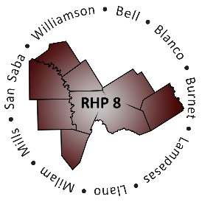
AGENDA

- Welcome/Introductions

- Review HHSC RHP Plan Update Templates and Guidance Documents
  - Documents Available on the HHSC Waiver Website
    - Program and Funding Mechanics (PFM) Protocol
    - Measure Bundle Protocol (MBP)
  - Documents Available on the HHSC Online DSRIP Reporting System Bulletin Board
    - Category B FAQ (posted 09/22/2017)
    - Category C FAQ (posted 01/19/2018)
    - Functional RHP Plan Update Template (posted 02/02/2018)
    - New Provider Functional RHP Plan Update Template (posted 02/02/2018)
    - RHP Plan Update Companion Document v3.pdf (posted 02/02/2018)
    - Category C Measure Specifications (posted 01/22/2018)
**Cohort participants are encouraged to bring print-outs of any listed references above
as copies will not be made available at the meeting. **
- Open Discussion/Questions and Answer

- Wrap-Up/Adjourn

