Regional Healthcare Partnerships 8 and 17
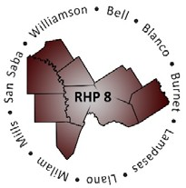
Joint Quarterly Regional Update
Wednesday, March 25, 2020
10:00 a.m. – 11:30 AM (via Zoom Webinar)
Texas A&M Health Science Center

Webinar Link: Join Zoom Meeting
Meeting Number: 503 146 263

Audio/Conference Line: Dial in: 877-931-8150; Code: 3621413

AGENDA

- Welcome/Introductions

- Texas 1115 Waiver Update (COVID-19 and DSRIP Transition)

- Uncompensated Care (UC) Update

- Delivery System Reform Incentive Payment (DSRIP) Update

- Other Waiver-Related Updates

- Open Q&A/Wrap-Up

