Regional Healthcare Partnerships 8 and 17
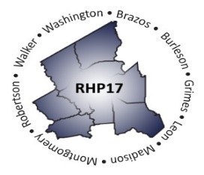
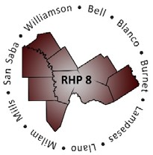
Joint Quarterly Regional Update
Thursday, December 16, 2021
10:30 AM – 12:00 PM (via Zoom Webinar)
Texas A&M University Health Science Center

Webinar Link: Join Zoom Meeting
Meeting Number: 927 7972 8651
Meeting Passcode: 944413

AGENDA

- Welcome/Introductions

- Brief Uncompensated Care (UC) Update

- Delivery System Reform Incentive Payment (DSRIP) Update
  - October DY10 Reporting and Payment Overview
  - April DY11 Reporting Reminders
  - DSRIP Transition Plan Updates/Considerations

- Texas 1115 Waiver Update
  - Brief 1115 Waiver Extension Update
    - Rescission, Appeal, and Injunction
    - Public Health Charity Care Pool
    - Post-DSRIP Directed Payment Programs
  - One-Year DSRIP Amendment (DY11 extension)

- Open Q&A/Wrap-Up

