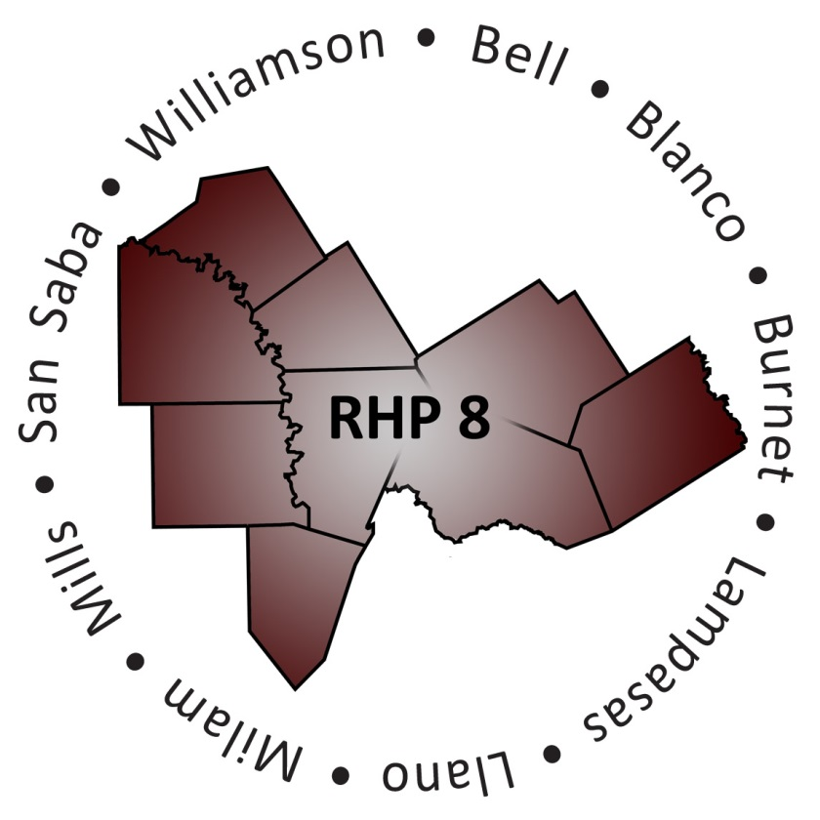

Regional Health Care Partnership (RHP) 8 Quick Facts
RHP 8 Anchor: Texas A&M Health Science Center
RHP 8 Counties: Bell, Blanco, Burnet, Lampasas, Llano, Milam,
Mills, San Saba, and Williamson
Total Population: 975,620 (US Census, 2015 Estimate)
Website: http://www.tamhsc.edu/1115-waiver/rhp8

Anticipated Total Funding to Region (2011-2016): Approximately $203 million
Federal Incentive: $119 million/IGT Local Funding: $84 million

Uncompensated Care: Approximately $99 million
Federal Incentive: $58 million/IGT Local Funding: $41 million

- Hospitals Participating in UC – 13
- Hospitals Participating in UC-Only – 8
- IGT Entities Supporting UC – 7
- IGT Entities Support UC-Only – 4

Note: Funds listed are Provider estimates submitted during initial planning; actual UC amounts set by annual cost reports filed by Providers and number of Providers participating in UC each year.

DSRIP Projects: Approximately $104 million
Federal Incentive: $61 million/IGT Local Funding: $43 million
- Performing Providers – 12
- Performing Providers in DSRIP-Only – 7
- IGT Entities Supporting DSRIP – 11
- IGT Entities Supporting DSRIP-Only – 8
- Category 1 and 2 – 40 (36 four-year; 4 three-year)
- Category 3 (outcome measures) – 54
- Category 4 (hospital only) – 6

DSRIP Projects by Performing Provider (Category 1 and 2 Projects)

- Bell County Public Health District – 2
- Bluebonnet Trails Community Services – 9
- Center for Life Resources – 1
- Central Counties Services – 9
- Hill Country MHDD Centers – 5
- Little River Healthcare – 2
- Scott and White Llano Hospital – 2
- Scott and White Memorial Hospital – 1
- Seton Harker Heights – 1
- Seton Highland Lakes – 1
- St. David’s Round Rock Medical Center – 1
- Williamson County and Cities Health District – 6

DSRIP Projects by Type (Category 1 and 2 Projects)

- Behavioral Health Services – 15
- Chronic Care and Disease Management – 2
- Primary Care Expansion – 5
- Health Promotion and Disease Prevention – 5
- Specialty Care – 1
- Performance/Process Improvement – 4
- Patient Care Navigation – 3
- Expand Capacity/Training Programs – 2
- Telemedicine – 3

DY3 – October DY6 Reported Regional Benefits

Provider Type | Individuals | Encounters
Community Mental Health Centers | 13.689 | 16,051
Hospitals | 4,716 | 167,255
Local Health Districts | 26,354 | 68,529
Total | 44,759 | 251,835
Note: Data in table are quantifiable patient impact numbers representing number of individuals OR encounters as reported by Provider type as of October DY6 report submission that are attributable to the DSRIP project. Individuals and Encounters above do not reflect three RHP 8 DSRIP projects in which data elements and social media posts are captured as encounters and individuals. If those three projects were included in the table above, total individuals would be 70,873 and total encounters would be 1,020,576.

