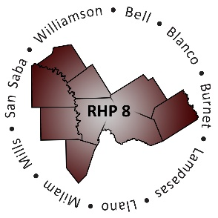
RHP 8 and RHP 17
DY8 Annual Learning Collaborative Event

Georgetown Health Foundation
Thursday, July 25, 2019
Community Rooms
9:30 a.m. – 4:00 p.m.
AGENDA
Time | Item/Speaker | Topics
9:30 am  10:00 am | Registration & Networking | Sign-in, Network
10:05 am  10:10 am | Shayna Spurlin  Associate Director, 1115 Anchor Teams  Texas A&M University Health Science Center | Welcome & Introductions
10:15 am  11:25 am | Dr. Robert Morrow  President, Houston and Southeast Texas  Blue Cross Blue Shield of Texas  Dr. Nancy Dickey  Executive Director, A&M Rural & Community Health Institute  Texas A&M University Health Science Center | Addressing the Rural Health Care Crisis: A Time for Innovation
11:30 am  12:15 pm | Quang Ngo  President, Foundation  Texas Organization of Rural & Community Hospitals (TORCH) | Rural Health in Texas
12:15 pm  1:00 pm | Lunch
1:05 pm  1:50 pm | John Cramer  Founder and Chief Transformation Catalyst  Radical Insight, Inc. | RTF Activity: A Trip to the Dark Side  Reverse Brainstorming for Sustainability Planning
1:55 pm  2:40 pm | Andy Vasquez  Deputy Associate Commissioner  Texas Health & Human Services Commission | Texas HHSC Initiatives and Direction
2:45 pm  3:30 pm | Ardas Khalsa  Consultant Policy Advisor  University of Texas Dell Medical School | Overview of Texas’ DSRIP Transition
3:35 pm  3:45 pm | Shayna Spurlin  Associate Director, 1115 Anchor Teams  Texas A&M Health Science Center | Closing Remarks

